Software Documentation

for

The Film Club Content Management System

Version 2.0 approved

Prepared by

Chad Golden

O’Neal Jones

Patrick Meehan

Lamar Sims

Matthew Stratton

Group #5

February 24, 2015

Executive Summary

This document is the *Software Specification* document for the Georgia Southern Film Club *Content Management System (CMS).* Provided will be an introduction to the system including the scope and purpose. Next the limitations and problems of the current system in place for the organization will be analyzed along with the plan for the solution proposed by the development team. The requirements for this proposed system will be elicited and analyzed in the form of *use cases*. Lastly, a glossary of technical terms will be provided, and a collection of diagrams and *user interface* designs will be provided in the Appendix along with the proposed project schedule which includes a diary of meetings and tasks amongst the developers and *stakeholders*.

Table of Contents

Executive Summary ii

Table of Contents iii

Revision History iv

1. Introduction 1

1.1 Purpose of the System 1

1.2 Scope of the System 1

1.3 Development Methodology 2

1.4 Definitions, Acronyms, and Abbreviations 2

1.5 Overview 3

2. Current System (Limitations and problems) 4

2.1 Existing System 4

3. Project Plan 5

3.1 Project Organization 6

3.2 Hardware and Software Requirements 7

3.3 Work Breakdown 8

4. Proposed System 9

4.1 Functional and Nonfunctional Requirements 9

4.2 Explanations of Diagrams for Implemented Use Cases 40

4.3 Requirements Analysis 42

5. Software Architecture 44

5.1 Overview 45

5.2 Subsystem Decomposition 47

5.3 Hardware and Software Mapping 49

5.4 Persistent Data Management 50

5.5 Security/Privacy 65

6. Detailed Design 67

6.1 Overview 67

6.2 Object Interaction 70

6.3 Detailed Class Design 72

7. Testing Process 73

7.1 Software Quality Assurance Plan 73

7.2 System Tests 74

7.3 Subsystem Tests 102

7.4 Evaluation of Tests 108

7.5 Testing Tools 112

8. Glossary 114

9. Appendix 116

9.1 Appendix A: Project Schedule 116

9.2 Appendix B: Diagrams 117

9.3 Appendix C: User Interface Designs 130

9.4 Class Diagrams 135

9.5 Class Interfaces 139

9.6 Testing 140

9.7 References 158

9.8 Appendix D: Diary of Meeting and Tasks 159

Revision History

**Table i-1** History of Changes

|  |  |  |  |
| --- | --- | --- | --- |
| **Name** | **Date** | **Reason For Changes** | **Version** |
| Team | 03/02/2015 | Software Requirements Specification | 1.0 |
| Team | 04/02/2015 | SRS Revision | 1.1 |
| Team | 05/01/2015 | Final Software Documentation | 2.0 |
|  |  |  |  |

# Introduction

This section is devoted to giving an overview of the contents in this *software specification* document. Provided are the scope of the system, its purpose, and a collection of definitions and abbreviations, and an overview of what to expect in the coming parts of this document.

## Purpose of the System

The purpose of the system is to provide the Georgia Southern Film Club with a useful set of tools to aid in the tasks involved within the organization. The proposed solution is a *content management system (CMS)* that will provide administration over information and media that the film club wishes to share over web pages accessible through the Internet.

## Scope of the System

The system shall allow for the public viewing of information pertinent to the organization and its members. Among the major benefits the system provides to the organization is the content management aspect of the solution. A user with administrative privileges to the website shall have the capability to add, edit, and delete relevant content to web pages through a simple to use interface. Through this interface, the system shall provide content management without possessing any software development skills.

The public shall be able to view basic information about the organization that is not limited to: the mission of the organization, what entities to contact for further information, news and blog, a roster, an event calendar, and media (e.g. images and videos). More specialized features shall be provided to users registered through a login system (e.g. posting to a discussion board and sending personal messages to an administrator of the organization).

The overarching benefit, objective, and goal is to provide a tool in order to assist the organization in the advancement its own endeavors using the proposed system.

## Development Methodology

The development team for the Film Club CMS exercised a software development method known as “agile software development”. Agile Alliance states that agile software development is a method that emphasized “close collaboration between the programmers and business experts; face-to-face communication; frequent delivery of new deployable business value; tight, self-organizing teams.”

Because the client was available for instant feedback for the implementations of the software requirements, the agile methodology was a good fit for the project. Meetings with client often composed of showing off the latest implementations on a weekly basis and eliciting additional requirements in the process.

The development team utilized *extreme programming (XP)* techniques that fall in line with agile methodology. The intent of the XP philosophy is to provide rapid development cycles. The development team adhered to this in order to gather feedback and further advance into more development cycles. Pair programming, another feature of the XP paradigm where the development team often had two members writing the software, provided on the spot code review and forced a coding style that each team member can comprehend and maintain.

## Definitions, Acronyms, and Abbreviations

**Table 1.3-1** Definitions, Acronyms, and Abbreviations

|  |  |
| --- | --- |
| **Term** | **Description** |
| CMS | *Content Management System.* A means for privileged users to add, edit, and remove content such as web pages, blog posts, and media through the aid of software. |
| Extreme Programming (XP) | A software development methodology whose intent is to provide rapid software release cycles and a high level of adaptability to changing stakeholder requirements. |

## Overview

The remainder of this document will cover topics pertinent to the Film Club CMS. These include: the limitations of the organization’s current system, the plan of execution for this project, the system’s requirements and analysis of these requirements, the architectural design of the software system, detailed design of the systems specific subsystem, the testing process, a glossary of terms, and an appendix containing graphical representations of some of the concepts found in the document.

# Current System (Limitations and problems)

This section will identify the specific problems and limitations of the current system provided for the Georgia Southern Film Club.

## Existing System

The current content management system the organization possesses is provided by the university to all student organizations. A major problem with the current system is that it is a “one-size-fits—all” solution. Nearly every website for each organization looks exactly the same. Aside from social media links, profile pictures, and contact information, the current system lacks distinguishing features in terms of appearance and content. In addition, the current website is difficult to find outside of a specific search query through a search engine. As a result of the current system’s shortcomings, the current system is rarely updated by the administrators because there is very little to update given the current feature set. Outside of the public obtaining general information (e.g. contact information), the system provides little worth to the club. Current members have no motivation to utilize the system as there is no feature that provides anything useful from their perspective.

The current system has eight navigation links which include: “Home”, “News”, “Profile”, “Events”, “Roster”, “Gallery”, “Documents”, and “Forms”. The “Home” page simply shows website users a profile picture, the goal of the organization, and the contact information for the organization. It also provides website users a button to join the organization and a direct connection to the film club on Facebook and Twitter. The “News” page currently contains no information. The “Profile” page merely restates the organization’s goals. The “Events” page shows both upcoming and past events; both fields are currently blank. The “Roster” page shows the user the officers and members of the film club. This page is the most utilized page of the current system as it contains the most information. The “Gallery” page shows users a collection of pictures of what the club has done in past events. The “Documents” page shows the constitution and bylaws of the organization. The “Forms” page shows forms that users must be signed in to view. As a whole, the website uses an identical layout across all webpages. If a page is not completely filled with information the page will contain a large void at the bottom of the screen.

# Project Plan

This section will outline the development team’s plan of tackling the project. The roles of the team members of the project will be specified. In addition some baseline hardware and software requirements will be examined that are necessary in order to deploy the application. Lastly, there will be a breakdown of the project milestones and deliverables.

## Project Organization

**Table 3.1-1** Project Team Member Roles

|  |  |  |
| --- | --- | --- |
| **Team Member** | **Role(s)** | **Description** |
| Chad Golden | 1. Project Leader 2. Database Administrator 3. Software Developer 4. Architectural Design | 1. Leads project. 2. Implements data requirements into database system. 3. Writes code for software. 4. In charge of designing the system architecture and module design. |
| O’Neal Jones | 1. Human-Computer Interaction 2. Software Developer 3. Author, User Manual | 1. Manages the usability of the system. 2. Writes code for software. 3. Authored the user manual. |
| Patrick Meehan | 1. Software Developer 2. Object-Oriented Design | 1. Writes code for software. 2. Models the required classes and objects for the application and this document. |
| Lamar Sims | 1. Software Testing Lead 2. Software Developer 3. Functional Testing Tool Specialist | 1. Extensively tests the software. 2. Writes code for software. 3. Organized and implemented Selenium for testing with the system. |
| Matthew Stratton | 1. Business Analyst 2. Software Developer 3. Software Testing Specialist | 1. Consults with the stakeholders. 2. Writes code for software. 3. Extensively tests the software. |

## Hardware and Software Requirements

The system was developed with both *PHP* and *HTML*. As an *IDE*, the team will use *PHP-Storm*, which is an integrated web development software by *JetBrains* where the team can easily pull all of the necessary HTML and PHP code online. For visual design, the team is using a popular web *framework* known as *Bootstrap*. This makes the design process much easier, and will make the website look much better.

On the *server* end, an *operating system* (Debian Linux or Microsoft Windows) is required to run the web software stack. At a minimum to run the required software stack (Apache Web Server + PHP + MySQL + Film Club CMS) the server machine needs to have at least 128 megabytes of RAM, an 800 MHz CPU, and one gigabyte of hard disk storage. To run smoothly and scale for the possibility of many simultaneous users, it is recommended the server have at a minimum: 2 gigabytes of RAM, a 3000 MHz dual-core CPU, and ten gigabytes of hard disk storage. In terms of disk storage, the system that uses the most of this resource is the media upload system. The system does place limits on the size (in terms of bytes) of media that can be uploaded to fit the constraints of limited hard disk space.

On the *client* end, there are no specific hardware requirements for the system other than having a device that runs a *web browser*. The system is optimized on both mobile and PC platforms. This is thanks to the Bootstrap framework. The system shall be optimized for the Google Chrome web browser, but other major browsers should display the website reasonably well.

## Work Breakdown

This identifies the milestones and deliverables for this project. Please refer to Appendix A for a graphical representation of these deliverables. Refer to Appendix B for a detailed log of operations among the *stakeholders* and team members.

**Table 3.3-1** Milestones and Deliverables

|  |  |  |
| --- | --- | --- |
| **Name of Deliverable** | **Date** | **Description** |
| SRS | 03/02/2015 | Software Requirements Specification. |
| SRS Presentation | 03/26/2015 | A brief description of the SRS. |
| Final Software Specification | 05/01/2015 | Written description of the software product. |
| Final Presentation | 05/05/2015 | An oral presentation of the software system delivered by the development team. |

# Proposed System

The system being developed for the GSU film club is aimed to provide members with an organized and collaborative environment to cultivate their interests. This is done by allowing club leaders and members to create profiles, events, project suggestions, and personal opinion discussions whereby an administrator can manage the content through a simple dashboard interface and users of the system without needing the low-level knowledge of how the system works under the hood. on one easy to use web system. Rather than relying on social media pages or email, the system gives members a home base to coordinate all club functions. Tools such as the calendar and discussion board allow the users to see a clear layout of upcoming events, and talk about ideas. Users not in the film club can learn more about it and have access to contact information.

Below is the core of this document that outlines the key features and requirements in the form of *use cases*.

## Functional and Nonfunctional Requirements

Listed here are the system’s use cases in tabular form. Individual use cases shall be referenced by their use-case identification (UCID) number that corresponds to their *4.1.X* headings (i.e. the first use-case is *UC-4.1.1*).

Diagrams of the subsystems pertaining to these use cases can be found in Appendix B.

### System Navigation

**Use Case 4.1-1** Traverse the Site/System

|  |  |
| --- | --- |
| **Function** | Navigate the System |
| **Description** | A visitor, account holder, or administrator navigates the site. |
| **Inputs** | Links, Navigation Bar Controls |
| **Actor** | Visitor, Account Holder, Film Club Member, or Administrator |
| **Source** | Actor |
| **Action** | The actor clicks a link on a webpage via a hyperlink or button, and the actor is redirected to the page indicated by the link or graphical element. |
| **Requirements** | The actor has an internet connection and a web browser. |
| **Pre-Condition** | The actor has navigated to the site in his or her web browser. |
| **Post-Condition** | N/A. |

### User Registration

**Use Case 4.1-2** User Registration

|  |  |
| --- | --- |
| **Function** | User Registration |
| **Description** | A visitor shall be able to register an account with the system. |
| **Inputs** | Username, Email, Password, and Password Confirmation. (Text) |
| **Actor** | Visitor |
| **Source** | Actor |
| **Action** | Inputs are taken in and evaluated to ensure specified Username and Email have not been used already and the password is of the minimum length. If specified information is valid then the information is saved for the actor.  Authentication Error: If the information specified is invalid, system will discard information and prompt actor for the information again. |
| **Requirements** | Refer to Table 4.1-1. |
| **Pre-Condition** | To not have a member already registered with the same username and email. |
| **Post-Condition** | Actor now holds an account with the system and is allowed to login. |

### User Login

**Use Case 4.1-3** User Login

|  |  |
| --- | --- |
| **Function** | User Login |
| **Description** | The system shall allow a user to sign-in as a member. |
| **Inputs** | Email and Password. (Text) |
| **Actor(s)** | Account Holder |
| **Source** | Actor |
| **Action** | Inputs are taken in and evaluated for validity against the information stored in the system. If specified inputs are valid then the actor is signed-in to the system.  Authentication Error: If the inputs specified by the actor is invalid, system will discard inputs and prompt actor for the inputs again. |
| **Requirements** | Refer to UC 4.1-3. |
| **Pre-Condition** | Actor must be registered in the system and not signed-in at the time of trying to sign-in. |
| **Post-Condition** | Actor is now signed-in to the system. |

### User Logout

**Use Case 4.1-4** User Logout

|  |  |
| --- | --- |
| **Function** | User Logout |
| **Description** | The system shall allow a user to sign out if they are signed in. |
| **Inputs** | The “Logout” button on the navigation bar. |
| **Actor(s)** | An account holder signed into the system |
| **Source** | Actor |
| **Action** | Actor clicks the logout button on the navigation bar. |
| **Requirements** | The navigation bar is visible. |
| **Pre-Condition** | Actor must be signed into the system. |
| **Post-Condition** | Actor is now signed out of the system. |

### Social Media Navigation

**Use Case 4.1-5** Social Media Navigation

|  |  |
| --- | --- |
| **Function** | Social Media Navigation |
| **Description** | A website user clicks one of the links to navigate to the Film Club’s profile on an external social media website. |
| **Inputs** | Mouse-click of one of the social media buttons. |
| **Actor(s)** | Any user of the website. |
| **Source** | Actor |
| **Action** | The actor clicks one of the social media buttons identified by the particular social media entity’s logo. These buttons are located within the footer of each page of the website. |
| **Requirements** | The actor is on a page where the website footer is visible. |
| **Pre-Condition** | See Table 4.1-1 |
| **Post-Condition** | The actor is now on a social media site external to the system. |

### Profile Image Creation

**Use Case 4.1-6** Profile Image Creation

|  |  |
| --- | --- |
| **Function** | Account Holder Uploads a Profile Image |
| **Description** | A website account holder should be allowed to upload their profile image. |
| **Inputs** | Image file (File Explorer Dialog) |
| **Actor(s)** | Account Holder |
| **Source** | Actor |
| **Action** | Actor will press upload image button and supply the image file through a file selection dialog. If successful image file will be saved for actor.  File Error: If unsuccessful inputs will be deleted and actor will be prompted to enter image file again. |
| **Requirements** | Actor is on their personal profile page. |
| **Pre-Condition** | Actor must be signed in. |
| **Post-Condition** | Actor now has a profile picture. |

### Profile Image Replacement

**Use Case 4.1-7** Profile Image Replacement

|  |  |
| --- | --- |
| **Function** | Replace Profile Image |
| **Description** | Should allow account holder to replace their profile image. |
| **Inputs** | Image file (File Explorer Dialog) |
| **Actor(s)** | Account Holder |
| **Source** | Actor |
| **Action** | Actor will press upload image button and supply the image file. If successful image file will be saved for actor.  File Error: If unsuccessful inputs will be deleted and actor will be prompted to enter image file again. |
| **Requirements** | Actor is on their profile page. |
| **Pre-Condition** | Actor is signed in and has a profile picture. |
| **Post-Condition** | Actor has changed profile picture. |

### Profile Image Deletion

**Use Case 4.1-8** Profile Image Deletion

|  |  |
| --- | --- |
| **Function** | Delete Profile Image |
| **Description** | An account holder should be allowed to delete their profile image. |
| **Inputs** | Delete Button (Mouse click) |
| **Actor(s)** | Account Holder |
| **Source** | Actor |
| **Action** | Actor presses button to delete profile image. If successful profile image will be deleted for actor.  File Error: If unsuccessful image will not be deleted, and actor must try again. |
| **Requirements** | Actor is on their profile page. |
| **Pre-Condition** | Actor is signed in and has a profile picture. |
| **Post-Condition** | Actor no longer has a profile picture. |

### Discussion Thread Creation

**Use Case 4.1-9** Discussion Thread Creation

|  |  |
| --- | --- |
| **Function** | Create a discussion thread |
| **Description** | Shall allow a member to create a discussion thread, which allows other members to reply to the created thread for discussion. |
| **Inputs** | Topic to be discussed  The body of text on the discussion topic. |
| **Actor(s)** | Account Holder |
| **Source** | Actor |
| **Action** | Actor will go to the discussion page and press the button to create a new thread. The actor will then be presented with a form to enter topic to be discussed and an empty field for the body of text on the discussion topic. The actor will then post and create the discussion thread. If successful the thread will now be viewable to other users and allowing other members to reply to the created thread.  Error: If unsuccessful actor will be prompted to try again or to enter a required input. |
| **Requirements** | Actor must be on the Discussion page. |
| **Pre-Condition** | Actor must be signed in. |
| **Post-Condition** | Actor's discussion thread is created and displayed in the discussion page. |

### Reply to a Discussion Thread

**Use Case 4.1-10** Reply to a Discussion Thread

|  |  |
| --- | --- |
| **Function** | Reply to a Discussion Thread |
| **Description** | Shall allow a member to create a sub-thread to another member’s discussion thread or sub-thread, which allows other members to reply to the created sub-thread. |
| **Inputs** | Body of text for the reply. |
| **Actor(s)** | Account Holder |
| **Source** | Actor. |
| **Action** | Actor will go to the discussion page and click reply to an existing discussion thread to make a reply. The actor will then be presented with an empty field, for the body of text, to reply. Once the actor is finished they will posts the reply. If successful the reply will now be viewable to other users and allowing other members to offer a reply.  Error: If unsuccessful actor will be prompted to try again. |
| **Requirements** | Actor must be on the discussion page and there must be a discussion thread to be replied to. |
| **Pre-Condition** | Actor must be signed in. |
| **Post-Condition** | Actor’s reply is now displayed in the discussion page under the discussion thread that was replied to. |

### Calendar Event Creation

**Use Case 4.1-11** Event Creation

|  |  |
| --- | --- |
| **Function** | Create an Event on the Calendar |
| **Description** | Shall allow a member to create an event and place it on the calendar, to be viewed by other users of the system. |
| **Inputs** | Name of event, date and time of event, location, description. |
| **Actor(s)** | Account Holder with Administrator Privileges |
| **Source** | Actor |
| **Action** | Actor will go to the events page and will then have to click the create events button, where they will be prompted with a form to fill out the events’ information. Once the actor is finished filling out the events form they can then save and create the event. If successful the event will be saved, created, and will be displayed in the calendar, on the events page.  Error: If unsuccessful the event will not be saved and created and the actor will be prompted to try again or ensure all required inputs have inputs. |
| **Requirements** | Actor must be on events page and the event being made must not conflict with another previous created events. |
| **Pre-Condition** | Actor must be signed in and have administrator privileges. |
| **Post-Condition** | Event is now created and displayed, in the calendar on the events page, to allow anyone to view. |

### Event Modification**

**Use Case 4.1-12** Edit an Event

|  |  |
| --- | --- |
| **Function** | Edit an event on the calendar |
| **Description** | Shall allow a user to edit a previously created event and redisplay the edited event. |
| **Inputs** | Name of event, date and time of event, location, description. |
| **Actor(s)** | Administrator |
| **Source** | Actor |
| **Action** | Actor will go to the events page and will then have to click on the previously created event, where they will be prompted with an option to edit the event, upon selecting edit a form to edit the events’ information will appear. Once the actor is finished editing the event they can then save and create the event again. If successful the event will be saved, created, and will be redisplayed.  Error: If unsuccessful the event will not be saved or created and the actor will be prompted to try again or to check the required inputs. |
| **Requirements** | Actor must be on the events page. |
| **Pre-Condition** | Actor must be signed in, must be an event available, and the edited event must not conflict with another previously created event. |
| **Post-Condition** | Event is now altered and displayed in the calendar on the events page to allow other users to view. |

### Event Deletion

**Use Case 4.1-13** Delete an Event

|  |  |
| --- | --- |
| **Function** | Delete an Event on the Calendar. |
| **Description** | Shall allow a user to delete a previously created event. |
| **Inputs** | Delete Button |
| **Actor(s)** | Administrator |
| **Source** | Actor |
| **Action** | Actor will go to the events page and will then have to click on the previously created event, where they will be prompted with an option to delete the event, upon selecting delete a confirmation will display to ensure action should be carried out. If successful event will be deleted.  Error: If unsuccessful the actor will be prompted to try again. |
| **Requirements** | Actor must be on the events page. |
| **Pre-Condition** | Actor must be signed-in, and there must be an event available to delete. |
| **Post-Condition** | Event is now deleted and is not displayed in the calendar on the events page anymore. |

### Calendar Navigation

**Use Case 4.1-14** Calendar Navigation

|  |  |
| --- | --- |
| **Function** | Navigate the Calendar |
| **Description** | A website user can use the arrow buttons on the calendar to view different months and the events have taken place or are to take place in the future. |
| **Inputs** | Arrow buttons indicating “Prev” (past) and “Next” (future) navigation of the calendar. |
| **Actor(s)** | Anyone viewing the site |
| **Source** | Actor |
| **Action** | The actor uses the “Prev” and “Next” buttons to navigate through the past, current, and future months on the calendar. Events on the calendar will appear as a clickable link. |
| **Requirements** | The actor is on the Events page. |
| **Pre-Condition** | N/A. |
| **Post-Condition** | N/A. |

### Custom Page Creation

**Use Case 4.1-15** Custom Page Creation

|  |  |
| --- | --- |
| **Function** | Administrator Creates a Page |
| **Description** | An administrator creates a page structured with a title, body, and comments. |
| **Inputs** | Create a Page Button,  Form Fields |
| **Actor(s)** | Administrator |
| **Source** | Actor |
| **Action** | The actor clicks the Custom Pages button on the dashboard menu. From there the actor fills a form containing the title, body content (this could contain text, images, or YouTube embeds). Upon completion of the form, the actor clicks the Submit button. If all input was valid the actor will be redirected to the newly created page.  Error: If the information is invalid, an error message will show and the actor will be prompted to reenter valid information. |
| **Requirements** | The actor is on the Dashboard page. |
| **Pre-Condition** | The actor is logged in. |
| **Post-Condition** | The actor has created a new page on the system that can be linked to and viewed by all. |

### Custom Page Modification

**Use Case 4.1-16** Custom Page Modification

|  |  |
| --- | --- |
| **Function** | Administrator Edits a Page |
| **Description** | An administrator edits a previously created custom page. See UC 4.1-15 |
| **Inputs** | Edit Button  Form Fields |
| **Actor(s)** | Administrator |
| **Source** | Actor |
| **Action** | The actors clicks the Edit Button located on the page he or she wishes to modify. The actor will fill out the form information as seen in the page creation process. The form will appear with the information filled in the fields that reflects the page’s current state. When satisfied with the changes, the actor will click the Submit button and he or she will be redirected to the newly modified page.  Error: If the information is invalid, an error message will show and the actor will be prompted to reenter valid information. |
| **Requirements** | The page the actor wishes to modify exists. |
| **Pre-Condition** | See Requirements and UC 4.1-15. |
| **Post-Condition** | The actor has modified the custom page. |

### Custom Page Deletion

**Use Case 4.1-17** Custom Page Deletion

|  |  |
| --- | --- |
| **Function** | Administrator Deletes a Page |
| **Description** | An administrator deletes a previously created page. |
| **Inputs** | Delete Button  Confirm Dialog |
| **Actor(s)** | Administrator |
| **Source** | Actor |
| **Action** | The administrator clicks the Delete button located on the page of interest. Upon pressing the button, the actor will confirm or cancel the deletion through a confirmation dialog. |
| **Requirements** | The page the actor wishes to delete exists. |
| **Post-Condition** | The actor has modified the custom page. |

### Administrator Reads Messages

**Use Case 4.1-18** Administrator Reads Messages

|  |  |
| --- | --- |
| **Function** | Administrator Reads Messages |
| **Description** | An administrator reads messages concerning potentially urgent matters. |
| **Inputs** |  |
| **Actor(s)** | Administrator |
| **Source** | Actor |
| **Action** | On the Dashboard page a list of messages will appear in the body of the page, sorted to where the newest messages are displayed first. Messages older than 30 days should be deleted automatically. |
| **Requirements** | The actor is on the Dashboard page. |
| **Pre-Condition** | The actor is signed in. |
| **Post-Condition** | The actor is able to read the messages. |

### Administrator Suspends User

**Use Case 4.1-19** Administrator Suspends User

|  |  |
| --- | --- |
| **Function** | Administrator Suspends Account Holder |
| **Description** | An administrator suspends the account of a problematic user. |
| **Inputs** | Dashboard View Users Button  Suspend User Button |
| **Actor(s)** | Administrator  Account Holder |
| **Source** | Actor |
| **Action** | The administrator clicks on the Manage Users Button on the Dashboard page. A list of the users on the website will appear. From this list the administrator may click the Suspend User Button next to the user’s record. This will disable the account holder’s profile. The account holder will now be unable to sign in. |
| **Requirements** | The actor is on the Dashboard page. |
| **Pre-Condition** | The actor is signed in. |
| **Post-Condition** | The actor has disabled the account of a problematic user. |

### Administrator Promotes Account Holder

**Use Case 4.1-20** Administrator Promotes Account Holder

|  |  |
| --- | --- |
| **Function** | Administrator Promotes Account Holder to Film Club Member Status |
| **Description** | An administrator promotes an account to film club member status. |
| **Inputs** | Dashboard View Users Button  Promote Button |
| **Actor(s)** | Administrator  Account Holder |
| **Source** | Actor |
| **Action** | The administrator clicks on the Manage Users Button on the Dashboard page. A list of the users on the website will appear. From this list the administrator may click the Promote User Button. This action will advance the account holder’s privilege level to that of a film club member. |
| **Requirements** | The actor is on the Dashboard page. |
| **Pre-Condition** | The actor is signed in. |
| **Post-Condition** | The actor has promoted the account to film club member status. |

### Administrator Adds to Videos Page

**Use Case 4.1-21** Administrator Adds to Videos Page

|  |  |
| --- | --- |
| **Function** | Administrator Adds Video to Videos Page |
| **Description** | The system shall allow admins to embed the club’s videos, project, and films to allow users of the system to easily view them. |
| **Inputs** | URL of YouTube video (The YouTube ID Number)  Embed Button |
| **Actor(s)** | Administrator  YouTube |
| **Source** | Actors |
| **Action** | Actor will go to the videos page. On the video page the actor will have to provide at least the YouTube ID and Video Description, and possibly Tags. Actor will then submit the video. |
| **Requirements** | Actor must be on the videos page. |
| **Pre-Condition** | Actor must be signed-in. |
| **Post-Condition** | Video will now be visible on the video page for all users to view. |

### Administrator Adds to Images Page

**Use Case 4.1-22** Administrator Adds to Images Page

|  |  |
| --- | --- |
| **Function** | Allow admin to embed pictures into the pictures page. |
| **Description** | The system shall allow admin of the GSU Film Club to embed pictures to allow users of the system to easily view them. |
| **Inputs** | Image file  Client file explorer dialog |
| **Actor(s)** | Administrator |
| **Source** | Actor. |
| **Action** | Actor will go to the pictures page. On the pictures page members will have to click the add picture button where they will provide the image file to embed the picture into the pictures page. |
| **Requirements** | Actor must be on the pictures page. |
| **Pre-Condition** | Actor must be signed-in as a member. |
| **Post-Condition** | Added pictures will now be visible on the pictures page, for all users to view. |

### User Makes Request or Suggestion to the Organization

**Use Case 4.1-23** System User Makes Request or Suggestion to the Organization

|  |  |
| --- | --- |
| **Function** | Make requests/suggestions for the GSU Film Club |
| **Description** | Shall allow a user to place a request/suggestion, for a film project or something else, to the GSU Film Club. |
| **Inputs** | Contact information:   * first name * last name * email address * phone number   Suggestion information:   * subject * body of text for the suggestion |
| **Actor(s)** | Any User of the System |
| **Source** | Actor |
| **Action** | Actor will go to the suggestions page. A form will then appear prompting the actor to provide their contact information and their suggestion. Actor must then submit the suggestion, which will then be sent to the GSU Film Club for an administrator to review. |
| **Requirements** | Actor must be on the suggestions page |
| **Pre-Condition** | N/A. |
| **Post-Condition** | Suggestion will be sent to GSU Film Club to be evaluated. |

### User Changes Personal Look and Feel of the System**

**Use Case 4.1-24** User Changes Personal Look and Feel of the System

|  |  |
| --- | --- |
| **Function** | User Changes the Template/Style of Web System. |
| **Description** | Should allow the changing of the template/style of the web system dynamically. |
| **Inputs** | Template/Style Selection Box |
| **Actor(s)** | Account Holder |
| **Source** | Actor |
| **Action** | Actor will only be allowed to click on the change template/style button. On clicking the button, actor will then be prompted to provide the template/style selection they desire. The system’s template/style will now be changed to the specified template/style. |
| **Requirements** | Actor must hold an account with the system. |
| **Pre-Condition** | User must be signed-in. |
| **Post-Condition** | The template/style of the web system will now be set to the specified template/style. |

### User Profile Modification**

**Use Case 4.1-25** User Profile Modification

|  |  |
| --- | --- |
| **Function** | Account Holder Edits Personal Profile |
| **Description** | Shall allow account holders within the system to edit their own personal profile upon registering. |
| **Inputs** | (Text fields) Name, phone #, interests, hobbies, age, grade. |
| **Actor(s)** | Account Holder |
| **Source** | Actor. |
| **Action** | Actor upon logging in or registering, actor will click next to where it says "Logged in as:" and select the drop down arrow. By pressing "Your Profile," the actor will be directed to their own personal account and can thus press edit to change existing information or add new information. |
| **Requirements** | Actor must hold an account with the system. |
| **Pre-Condition** | Actor is logged in and has pressed the edit button on their profile page. |
| **Post-Condition** | The new information is saved to their profile. |

### Contact Information Retrieval

**Use Case 4.1-26** Retrieve Contact Information

|  |  |
| --- | --- |
| **Function** | Find out contact information for the GSU Film club. |
| **Description** | Shall allow visitors or users of the GSU Film Club website to access and view contact information. |
| **Inputs** | Text-fields:   * Name * phone number * interests * hobbies * age * grade |
| **Actor(s)** | Visitor  User  Admin |
| **Source** | Actor. |
| **Action** | Actor will click on the "About" button at the top navigation bar. A drop down menu will then be displayed. The actor will click on the "Contact" selection. This will re navigate them to the "Contact" page. |
| **Requirements** | N/A. |
| **Pre-Condition** | Actor is on the website. |
| **Post-Condition** | The contact information is displayed. |

### Contact Information Modification

**Use Case 4.1-27** Modify Contact Information

|  |  |
| --- | --- |
| **Function** | An Administrator Edits Contact Information |
| **Description** | The system shall allow an admin of the GSU Film club to change the information on the contact page if need be. |
| **Inputs** | Address  Email |
| **Actor(s)** | Admin |
| **Source** | Actor |
| **Action** | The Actor will click the Site Information button, to go to the site information page. They will then see the "Contact Us" dialog with the current contact information displayed. The actor will write in the current contact information in the body text field. The actor will then click the Submit Changes button and update the contact information. |
| **Requirements** | N/A. |
| **Pre-Condition** | Actor is logged in as an admin. |
| **Post-Condition** | The new contact information is displayed on the "Contact" page. |

### Registration Failure

**Use Case 4.1-28 Failure to Register**

|  |  |
| --- | --- |
| **Function** | Failing to register as a member |
| **Description** | Shall happen when the user fails to enter proper information when registering as a member. |
| **Inputs** | Text-fields:   * Username * Email * Password * Password Confirmation |
| **Actor(s)** | Visitor |
| **Source** | Actor |
| **Action** | If Username and Email are already in the system, then actor is prompted to enter different Username and Email until there is no conflict with other members of the system. If password is not of the minimum length then actor will be prompted to enter another password until minimum length is met. If actor enters any other password then the one they specified in Password Confirmation, they will be prompted to re-enter the Password Confirmation until it matches initial password entered. |
| **Requirements** | Actor enters invalid Username, Email, Password, and/or Password Confirmation |
| **Pre-Condition** | N/A. |
| **Post-Condition** | Actor enters new information after being prompted to change their initial information. |

### Add User Roles

**Use Case 4.1-29 Add User Roles**

|  |  |
| --- | --- |
| **Function** | An Administrator Adds a new User Role |
| **Description** | Shall allow an admin of the GSU Film club to add an individual role to the list of roles. |
| **Inputs** | Text-fields:   * Role Name * Role Description |
| **Actor(s)** | Admin |
| **Source** | Actor |
| **Action** | The Actor will visit the "Manage User Roles" on the left of the dashboard window. The Actor will now enter the Role Name and Role Description, and then click "Submit." |
| **Requirements** | User is logged into an administrator account. |
| **Pre-Condition** | Actor is logged in as an admin and on the Dashboard Page |
| **Post-Condition** | The new role will be listed under "Current Roles." |

### Manage User Roles

**Use Case 4.1-30** Modify Contact Information

|  |  |
| --- | --- |
| **Function** | An Administrator can assign roles to individual club members. |
| **Description** | The system shall allow an admin of the GSU Film club to manage the roles of the members of the GSU Film Club. |
| **Inputs** | Set New Role |
| **Actor(s)** | Admin |
| **Source** | Actor |
| **Action** | The Actor will navigate to the "Manage Roles of Current Members" panel. From there, the Admin will find the user that they would like to assign a role. Under "New Role" they will click the drop down arrow and assign the particular role to the user. The Admin will then click "Set." |
| **Requirements** | User is an Admin. |
| **Pre-Condition** | Actor is logged in as an admin and on the Dashboard page. |
| **Post-Condition** | The User now has an updated role. |

**\*\****Denotes that the feature has not yet been implemented (NYI)****.***

## Explanations of Diagrams for Implemented Use Cases

### Basic Website Navigation Subsystem (Figure 6.2.1-1, Appendix)

* An actor (any person viewing the application) is able to traverse the system via the navigation bar, submit a suggestion via the suggestion submission page, and follow the organizations link to an external social media outlet.

### Login Subsystem (Figure 6.2.2-1, Appendix)

* A visitor may register an account to log into the system.
* An account holder with the system may sign in and sign out to end a session with the application.
* A club member (an account holder with elevated privileges) is able to flag other account holders as film club members.

### User Profile Subsystem (Figure 6.2.3-1, Appendix)

* An account holder may add, change, or remove their profile image for their account.

### Administrative Tools Subsystem (Figure 6.2.4-1, Appendix)

* An administrator may:
  + Add, change, and remove custom pages.
  + Read messages from the suggestions system.
  + Promote, demote, and suspend account holders of the system.
  + Add videos that will be displayed on the public videos page.
  + Add images that will be displayed on the public pictures page.

### Discussion Subsystem (Figure 6.2.5-1, Appendix)

* Any application user (including the general public) may view discussion posts posted by account holders of the system (On the main discussion board page or custom page discussions).
* An account holder of the system in addition to viewing may create and reply to other posts.

### Calendar of Events Subsystem (Figure 6.2.6-1, Appendix)

* Any application user, account holder, club member, and administrator may view events and navigate the calendar.
* Club members and administrators may add and remove events from the calendar.

## Requirements Analysis

Contained here are brief explanations of the varied subsystems and their requirements within the whole system. Refer to Appendix B for the diagrammatic representations of these subsystems.

### Data Requirements

The Data Requirements diagram in *Appendix A Figure 6.1-1* outlines the necessary data in order to implement features articulated by the requirements.

### Website Navigation Subsystem

*Figure 6.2.1-1* shows the features as a set of use cases that are integral to the Website Navigation Subsystem.

*Figure 6.2.1-2* shows the flow of logic between the user and the system in order to communicate suggestions to the administrators.

### Login Subsystem

*Figure 6.2.2-1* illustrates the functional requirements of the Login Subsystem.

*Figure 6.2.2-2* shows the sequence of events that take place between the user and components of the system during the account registration process.

### User Profile Subsystem

*Figure 6.2.3-1* lays out the features of the User Profile Subsystem that are to be utilized by account holders.

*Figure 6.2.3-2* illustrates the steps taken by the parts of the system in order to delete a user profile image.

### Administrative Tools Subsystem

*Figure 6.2.4-1* shows the tasks an administrator may complete.

*Figure 6.2.4-2* shows the series of actions that take place within the system when an administrator wants to view messages.

### Discussion Subsystem

*Figure 6.2.5-1* shows the requirements of the Discussion Message Subsystem.

*Figure 6.2.5-2* shows the sequence of events that occur within the system when any user of the system wants to view a discussion.

### Calendar of Events Subsystem

*Figure 6.2.6-1* expresses the necessary features the Calendar of Events Subsystem should provide.

*Figure 6.2.6-2* displays the steps taken by the components within the system when any person viewing the system navigates the calendar.

# Software Architecture

The system utilizes two software architectural patterns. The overall goal of these patterns is to adhere with the Open-Closed Principle of the object-oriented programming paradigm. The Open-Closed Principle states that “*software entities (classes, modules, functions, etc.) should be open for extension, but closed for modification.*” (Meyer, B.)

One of the patterns is called the *Front Controller* pattern. This pattern is commonly used in web applications and the frameworks on which they are built. The goal is for the application to have a main entry point (in the case of the Film Club CMS, the “index.php” in the application’s root file directory) for which all requests funnel through. This encourages a modular implementation of the underlying structure of the application.

The next pattern the Film Club CMS utilizes is the *Hierarchical Model-View-Controller* (HMVC) software architectural pattern. The goal of this pattern is to divide the structure of the classes in the application into logical widgets in order to decouple the subsystems and have the subsystems operate independently of each other. The end result is that features may be modified and added without the need to modify existing widgets.

## Overview

Below is the package diagram outlining a (hierarchical) Model-View-Controller (HMVC) software architecture pattern between the base controller class (MY_Controller) and models and views within the system. Any model and view may utilize the attributes and functions of the base controller.

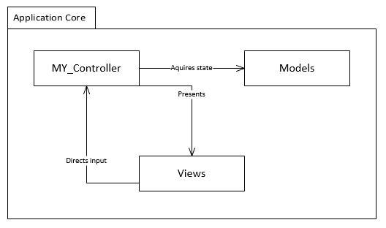

At the application’s core are the top-level MVC components. This package contains the application’s super controller (MY_Controller) that stores data to be passed to a view (An abstracted operation common to all controllers). The view may direct input to the controller where it may process the desired operations. The data stored by the controller may include stateful information stored in the database. This is done through interaction with the model classes.

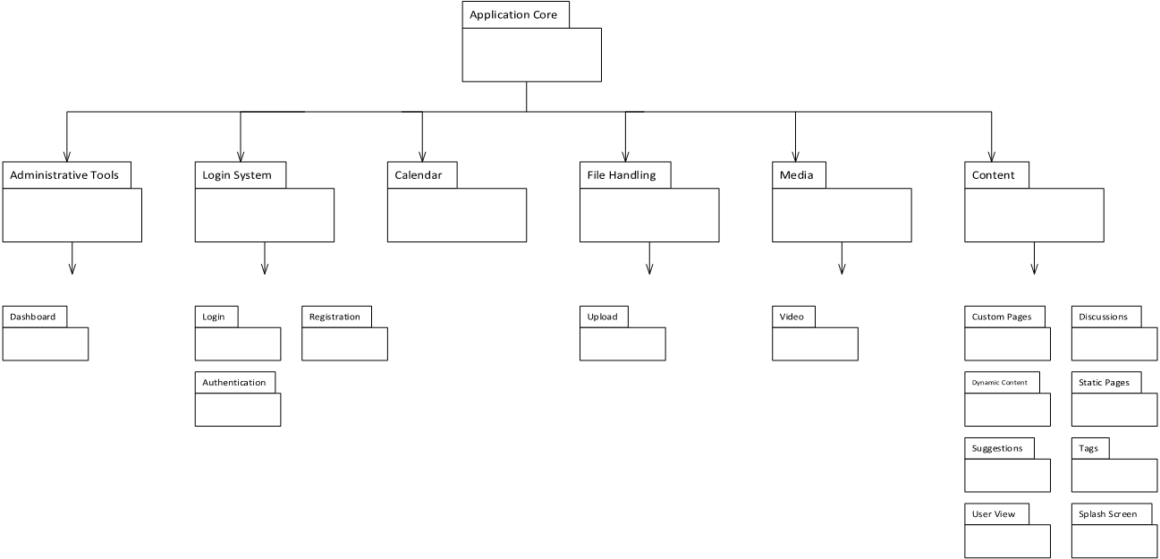

The above diagram shows the hierarchy packages of the application in their entirety. The two architectural patterns are clearly here visible here. The application core contains the Front Controller (MY_Controller) as part of the Front Controller pattern. The Hierarchical MVC pattern is directly illustrated by the hierarchy of packages containing more specialized controller classes.

For the purposes of this diagram each second-level package represents a subsystem. Each package represents a set of MVC components. A brief description of each subsystem follows.

## Subsystem Decomposition

Below is a mapping of the system modules with the specific use cases.

### Administrative Tools

This is responsible for dashboard activities such as creating new content and user management. Encompasses use cases (UCID):

* UC#4.1-15
* UC#4.1-16
* UC#4.1-17
* UC#4.1-18
* UC#4.1-19
* UC#4.1-20
* UC#4.1-21
* UC#4.1-22

### Login System

This handles the authentication and registration processes. Encompasses use cases (UCID):

* UC#4.1-2
* UC#4.1-3
* UC#4.1-4

### Calendar System

This is responsible for the viewing and creation of events on the calendar. Encompasses use cases (UCID):

* UC#4.1-11
* UC#4.1-13
* UC#4.1-14

### File Handling System

This manages the storage of files on the server. Encompasses use cases (UCID):

* UC#4.1-6
* UC#4.1-7
* UC#4.1-8

### Media System

Responsible for the presentation, creation, and organization of club videos. Encompasses use cases (UCID):

* UC#4.1-21
* UC#4.1-22

### Content

The largest subsystem. It is responsible for the management of dynamic content. Encompasses use cases (UCID):

* UC#4.1-26
* UC#4.1-27
* UC#4.1-29
* UC#4.1-30

## Hardware and Software Mapping

The Film Club CMS runs completely on a server machine that has the required software stack installed (See hardware and software requirements).

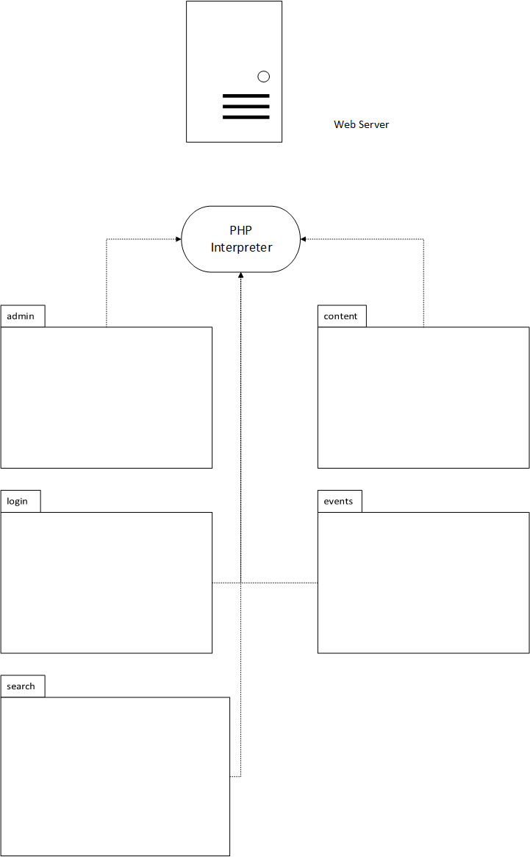

## Persistent Data Management

The persistent data required by the application is provided by a MySQL database management system server located on the host machine. As typical with most database management systems, the data is organized into tables. Other schema objects include database views, stored procedures, and triggers.

The goal of the database views is to provide a simpler interface for the application domain to interact with the database system. For example the “custom_pages_with_authors” removes a need for the PHP application code to have knowledge of the relationships and joins required of the tables.

The stored procedures and triggers provide similar benefits in that the PHP application code need not manage all of the individual transactions. That responsibility is deferred to the MySQL database system to where the transactions are done in a simpler, safer way.

The next page contains the schema definition of the Film Club CMS in the form of Entity-Relationship diagrams:

**Figure 5.4.1** Entity Relationship Diagram of Related Entities of the Film Club CMS

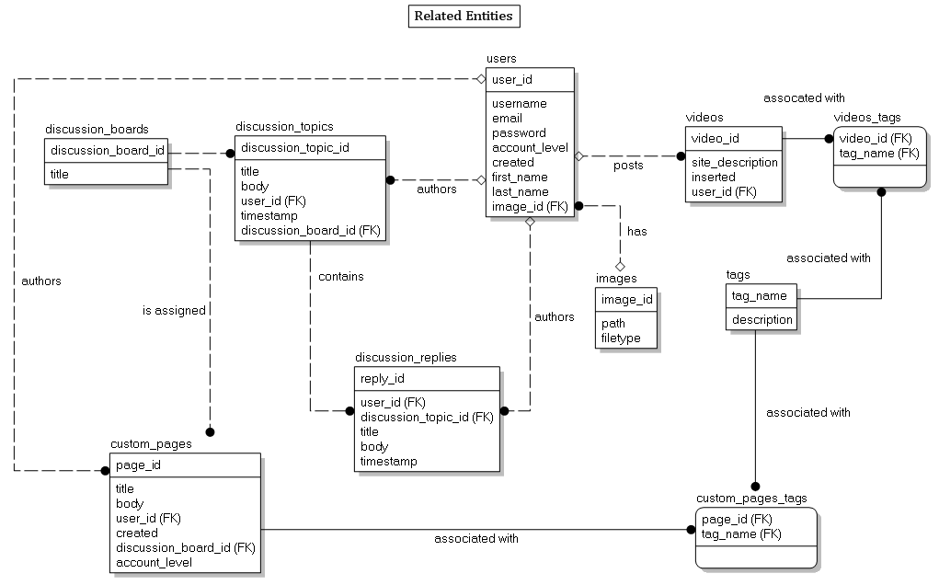

**Figure 5.4.2** Diagram of Isolated Storage Tables within the Database

These tables are required only for their storage capabilities for simple persistent data needs. The “ci_sessions” table saves session information for users after the application has halted on the client end. The “events” table stores the necessary information for the events subsystem. The “dynamic_content” table allows for simple storage of the content of the information pages within the website. The “suggestions” table handles the storage for the suggestion submission system. Because there are no membership requirements, the table does not require any foreign key constraints.

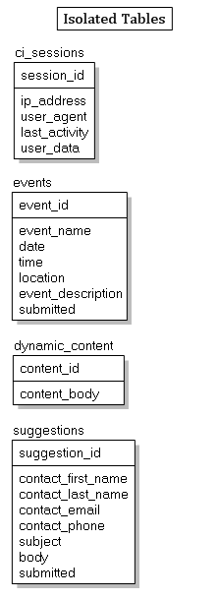

### Data Dictionary

Below are the database tables and views used by the Film Club CMS.

**ci_sessions**

This table is used to store sessions for the application.

|  |  |  |  |  |
| --- | --- | --- | --- | --- |
| **Column** | **Type** | **Null** | **Default** | **Comments** |
| session_id | varchar(40) | No | 0 |  |
| ip_address | varchar(45) | No | 0 |  |
| user_agent | varchar(120) | No |  |  |
| last_activity | int(10) | No | 0 |  |
| user_data | text | No |  |  |

**Indexes**

| **Keyname** | **Type** | **Unique** | **Packed** | **Column** | **Cardinality** | **Collation** | **Null** | **Comment** |
| --- | --- | --- | --- | --- | --- | --- | --- | --- |
| PRIMARY | BTREE | Yes | No | session_id | 7 | A | No |  |
| last_activity_idx | BTREE | No | No | last_activity | 7 | A | No |  |

**custom_pages**

Stores the records for the custom pages. Each custom page is assigned a discussion board via an pre-insertion trigger.

|  |  |  |  |  |
| --- | --- | --- | --- | --- |
| **Column** | **Type** | **Null** | **Default** | **Comments** |
| page_id | int(11) | No |  |  |
| title | varchar(100) | No |  |  |
| body | text | No |  |  |
| user_id | int(11) | Yes | *NULL* |  |
| created | timestamp | Yes | CURRENT_TIMESTAMP |  |
| discussion_id | int(11) | Yes | *NULL* |  |
| discussion_board_id | int(11) | No |  |  |
| account_level | tinyint(4) | Yes | -1 |  |

**Indexes**

| **Keyname** | **Type** | **Unique** | **Packed** | **Column** | **Cardinality** | **Collation** | **Null** | **Comment** |
| --- | --- | --- | --- | --- | --- | --- | --- | --- |
| PRIMARY | BTREE | Yes | No | page_id | 11 | A | No |  |
| user_id | BTREE | No | No | user_id | 11 | A | Yes |  |
| custom_pages_ibfk_2 | BTREE | No | No | discussion_id | 11 | A | Yes |  |
| discussion_board_id | BTREE | No | No | discussion_board_id | 11 | A | No |  |

**custom_pages_comments_authors**

View that joins the custom pages, discussion board, and users table for use by the application.

Table comments: VIEW

|  |  |  |  |  |
| --- | --- | --- | --- | --- |
| **Column** | **Type** | **Null** | **Default** | **Comments** |
| page_id | int(11) | No | 0 |  |
| title | varchar(100) | No |  |  |
| body | text | No |  |  |
| user_id | int(11) | No | 0 |  |
| username | varchar(20) | No |  |  |
| created | timestamp | Yes | *NULL* |  |
| discussion_board_id | int(11) | No |  |  |
| comments | bigint(21) | No | 0 |  |

**custom_pages_tags**

Emcompasses the many-to-many relationship of custom pages to tags.

|  |  |  |  |  |
| --- | --- | --- | --- | --- |
| **Column** | **Type** | **Null** | **Default** | **Comments** |
| page_id | int(11) | No |  |  |
| tag_name | varchar(30) | No |  |  |

**Indexes**

| **Keyname** | **Type** | **Unique** | **Packed** | **Column** | **Cardinality** | **Collation** | **Null** | **Comment** |
| --- | --- | --- | --- | --- | --- | --- | --- | --- |
| PRIMARY | BTREE | Yes | No | page_id | 1 | A | No |  |
| tag_name | 1 | A | No |
| tag_name | BTREE | No | No | tag_name | 1 | A | No |  |

**discussion_boards**

This table defines a discussion board record. Discussion boards are intended to be associated with discussion topics.

|  |  |  |  |  |
| --- | --- | --- | --- | --- |
| **Column** | **Type** | **Null** | **Default** | **Comments** |
| discussion_board_id | int(11) | No |  |  |
| title | varchar(50) | No |  |  |

**Indexes**

| **Keyname** | **Type** | **Unique** | **Packed** | **Column** | **Cardinality** | **Collation** | **Null** | **Comment** |
| --- | --- | --- | --- | --- | --- | --- | --- | --- |
| PRIMARY | BTREE | Yes | No | discussion_board_id | 14 | A | No |  |

**discussion_boards_number_of_comments**

This view joins the discussion_boards table with the discussion_topics table to summarize the number of comments for the application to use.

Table comments: VIEW

|  |  |  |  |  |
| --- | --- | --- | --- | --- |
| **Column** | **Type** | **Null** | **Default** | **Comments** |
| discussion_board_id | int(11) | No | 0 |  |
| number_of_comments | bigint(21) | No | 0 |  |

**discussion_replies**

This table stores the replies to discussion topics. Each discussion reply is associated with a single discussion topic.

|  |  |  |  |  |
| --- | --- | --- | --- | --- |
| **Column** | **Type** | **Null** | **Default** | **Comments** |
| reply_id | int(11) | No |  |  |
| user_id | int(11) | Yes | *NULL* |  |
| discussion_topic_id | int(11) | No |  |  |
| title | varchar(100) | Yes | *NULL* |  |
| body | text | No |  |  |
| timestamp | timestamp | No | CURRENT_TIMESTAMP |  |

**Indexes**

| **Keyname** | **Type** | **Unique** | **Packed** | **Column** | **Cardinality** | **Collation** | **Null** | **Comment** |
| --- | --- | --- | --- | --- | --- | --- | --- | --- |
| PRIMARY | BTREE | Yes | No | reply_id | 30 | A | No |  |
| user_id | BTREE | No | No | user_id | 10 | A | Yes |  |
| discussion_topic_id | BTREE | No | No | discussion_topic_id | 30 | A | No |  |

**discussion_replies_with_authors**

This view joins the discussion_replies table with the authors table for the application to use.

Table comments: VIEW

|  |  |  |  |  |
| --- | --- | --- | --- | --- |
| **Column** | **Type** | **Null** | **Default** | **Comments** |
| body | text | No |  |  |
| discussion_topic_id | int(11) | No |  |  |
| reply_id | int(11) | No | 0 |  |
| timestamp | timestamp | No | 0000-00-00 00:00:00 |  |
| username | varchar(20) | Yes | *NULL* |  |

**discussion_topics**

This table contains the records for discussion topics. Discussion topics belong to a discussion board.

|  |  |  |  |  |
| --- | --- | --- | --- | --- |
| **Column** | **Type** | **Null** | **Default** | **Comments** |
| discussion_topic_id | int(11) | No |  |  |
| title | varchar(100) | No |  |  |
| body | text | No |  |  |
| user_id | int(11) | Yes | *NULL* |  |
| timestamp | timestamp | No | CURRENT_TIMESTAMP |  |
| discussion_board_id | int(11) | No |  |  |

**Indexes**

| **Keyname** | **Type** | **Unique** | **Packed** | **Column** | **Cardinality** | **Collation** | **Null** | **Comment** |
| --- | --- | --- | --- | --- | --- | --- | --- | --- |
| PRIMARY | BTREE | Yes | No | discussion_topic_id | 18 | A | No |  |
| user_id | BTREE | No | No | user_id | 4 | A | Yes |  |
| discussion_board_id | BTREE | No | No | discussion_board_id | 18 | A | No |  |

**discussion_topics_with_authors**

This view joins the users and discussion_topics table for use by the application.

Table comments: VIEW

|  |  |  |  |  |
| --- | --- | --- | --- | --- |
| **Column** | **Type** | **Null** | **Default** | **Comments** |
| body | text | No |  |  |
| title | varchar(100) | No |  |  |
| discussion_topic_id | int(11) | No | 0 |  |
| discussion_board_id | int(11) | No |  |  |
| timestamp | timestamp | No | 0000-00-00 00:00:00 |  |
| username | varchar(20) | Yes | *NULL* |  |

**discussions_for_custom_page**

This joins the discussions and custom_pages tables.

Table comments: VIEW

|  |  |  |  |  |
| --- | --- | --- | --- | --- |
| **Column** | **Type** | **Null** | **Default** | **Comments** |
| page_id | int(11) | No | 0 |  |
| discussion_id | int(11) | No | 0 |  |
| reply_id | int(11) | Yes | *NULL* |  |
| title | varchar(100) | No |  |  |
| body | text | No |  |  |
| user_id | int(11) | Yes | *NULL* |  |
| timestamp | timestamp | No | 0000-00-00 00:00:00 |  |

**dynamic_content**

This table simply stores content for a static page.

|  |  |  |  |  |
| --- | --- | --- | --- | --- |
| **Column** | **Type** | **Null** | **Default** | **Comments** |
| content_id | varchar(32) | No |  |  |
| content_body | text | No |  |  |

**Indexes**

| **Keyname** | **Type** | **Unique** | **Packed** | **Column** | **Cardinality** | **Collation** | **Null** | **Comment** |
| --- | --- | --- | --- | --- | --- | --- | --- | --- |
| PRIMARY | BTREE | Yes | No | content_id | 2 | A | No |  |

**events**

This table stores the records for the event pages for use by the calendar.

|  |  |  |  |  |
| --- | --- | --- | --- | --- |
| **Column** | **Type** | **Null** | **Default** | **Comments** |
| event_id | int(11) | No |  |  |
| event_name | varchar(50) | No |  |  |
| date | date | No |  |  |
| time | time | No |  |  |
| location | varchar(50) | No |  |  |
| event_description | varchar(1000) | No |  |  |
| submitted | timestamp | No | CURRENT_TIMESTAMP |  |

**Indexes**

| **Keyname** | **Type** | **Unique** | **Packed** | **Column** | **Cardinality** | **Collation** | **Null** | **Comment** |
| --- | --- | --- | --- | --- | --- | --- | --- | --- |
| PRIMARY | BTREE | Yes | No | event_id | 13 | A | No |  |

**images**

This stores the name (the primary key ID), path, and file type of images.

|  |  |  |  |  |
| --- | --- | --- | --- | --- |
| **Column** | **Type** | **Null** | **Default** | **Comments** |
| image_id | int(11) | No |  |  |
| path | varchar(256) | No |  |  |
| filetype | varchar(10) | No |  |  |

**Indexes**

| **Keyname** | **Type** | **Unique** | **Packed** | **Column** | **Cardinality** | **Collation** | **Null** | **Comment** |
| --- | --- | --- | --- | --- | --- | --- | --- | --- |
| PRIMARY | BTREE | Yes | No | image_id | 21 | A | No |  |

**non_user_images**

This view does an anti-join of the users and images tables to display images not assigned to a user.

Table comments: VIEW

|  |  |  |  |  |
| --- | --- | --- | --- | --- |
| **Column** | **Type** | **Null** | **Default** | **Comments** |
| image_id | int(11) | No | 0 |  |
| filetype | varchar(10) | No |  |  |
| path | varchar(256) | No |  |  |

**roles**

This table stores the roles records.

|  |  |  |  |  |
| --- | --- | --- | --- | --- |
| **Column** | **Type** | **Null** | **Default** | **Comments** |
| role_id | int(11) | No |  |  |
| role_name | varchar(50) | No |  |  |
| role_description | varchar(256) | Yes | *NULL* |  |

**Indexes**

| **Keyname** | **Type** | **Unique** | **Packed** | **Column** | **Cardinality** | **Collation** | **Null** | **Comment** |
| --- | --- | --- | --- | --- | --- | --- | --- | --- |
| PRIMARY | BTREE | Yes | No | role_id | 4 | A | No |  |

**Suggestions**

This table stores the suggestion records for the suggestion message system.

|  |  |  |  |  |
| --- | --- | --- | --- | --- |
| **Column** | **Type** | **Null** | **Default** | **Comments** |
| suggestion_id | int(11) | No |  |  |
| contact_first_name | varchar(30) | No |  |  |
| contact_last_name | varchar(30) | No |  |  |
| contact_email | varchar(50) | No |  |  |
| contact_phone | varchar(20) | No |  |  |
| subject | varchar(50) | No |  |  |
| body | varchar(5000) | No |  |  |
| submitted | timestamp | No | CURRENT_TIMESTAMP |  |

**Indexes**

| **Keyname** | **Type** | **Unique** | **Packed** | **Column** | **Cardinality** | **Collation** | **Null** | **Comment** |
| --- | --- | --- | --- | --- | --- | --- | --- | --- |
| PRIMARY | BTREE | Yes | No | suggestion_id | 7 | A | No |  |

**tags**

This table stores the tag records.

|  |  |  |  |  |
| --- | --- | --- | --- | --- |
| **Column** | **Type** | **Null** | **Default** | **Comments** |
| tag_name | varchar(30) | No |  |  |
| description | varchar(100) | Yes | *NULL* |  |

**Indexes**

| **Keyname** | **Type** | **Unique** | **Packed** | **Column** | **Cardinality** | **Collation** | **Null** | **Comment** |
| --- | --- | --- | --- | --- | --- | --- | --- | --- |
| PRIMARY | BTREE | Yes | No | tag_name | 7 | A | No |  |

**unit_test_results**

For developer use only. This table stores the results of unit tests.

|  |  |  |  |  |
| --- | --- | --- | --- | --- |
| **Column** | **Type** | **Null** | **Default** | **Comments** |
| test_id | int(11) | No |  |  |
| test_name | varchar(30) | No |  |  |
| test_datatype | varchar(30) | Yes | *NULL* |  |
| expected_datatype | varchar(30) | Yes | *NULL* |  |
| result | varchar(10) | Yes | *NULL* |  |
| file_name | varchar(100) | Yes | *NULL* |  |
| line_number | int(11) | Yes | *NULL* |  |
| notes | varchar(200) | Yes | *NULL* |  |
| timestamp | timestamp | No | CURRENT_TIMESTAMP |  |

**Indexes**

| **Keyname** | **Type** | **Unique** | **Packed** | **Column** | **Cardinality** | **Collation** | **Null** | **Comment** |
| --- | --- | --- | --- | --- | --- | --- | --- | --- |
| PRIMARY | BTREE | Yes | No | test_id | 2 | A | No |  |

**Users**

This table stores the user information.

|  |  |  |  |  |
| --- | --- | --- | --- | --- |
| **Column** | **Type** | **Null** | **Default** | **Comments** |
| user_id | int(11) | No |  |  |
| username | varchar(20) | No |  |  |
| email | varchar(30) | No |  |  |
| password | varchar(60) | No |  |  |
| account_level | int(11) | Yes | 0 |  |
| created | timestamp | Yes | CURRENT_TIMESTAMP |  |
| first_name | varchar(50) | Yes | *NULL* |  |
| last_name | varchar(50) | Yes | *NULL* |  |
| image_id | int(11) | Yes | *NULL* |  |
| role_id | int(11) | Yes | *NULL* |  |

**Indexes**

| **Keyname** | **Type** | **Unique** | **Packed** | **Column** | **Cardinality** | **Collation** | **Null** | **Comment** |
| --- | --- | --- | --- | --- | --- | --- | --- | --- |
| PRIMARY | BTREE | Yes | No | user_id | 31 | A | No |  |
| email | BTREE | Yes | No | email | 31 | A | No |  |
| fk_user_image_id | BTREE | No | No | image_id | 6 | A | Yes |  |

**Videos**

This table stores the video using the YouTube video ID number.

|  |  |  |  |  |
| --- | --- | --- | --- | --- |
| **Column** | **Type** | **Null** | **Default** | **Comments** |
| video_id | varchar(30) | No |  |  |
| site_description | text | Yes | *NULL* |  |
| inserted | timestamp | No | CURRENT_TIMESTAMP |  |
| user_id | int(11) | Yes | *NULL* |  |

**Indexes**

| **Keyname** | **Type** | **Unique** | **Packed** | **Column** | **Cardinality** | **Collation** | **Null** | **Comment** |
| --- | --- | --- | --- | --- | --- | --- | --- | --- |
| PRIMARY | BTREE | Yes | No | video_id | 8 | A | No |  |
| user_id | BTREE | No | No | user_id | 8 | A | Yes |  |

**videos_tags**

This table stores the many-to-many association between the videos and tags tables.

|  |  |  |  |  |
| --- | --- | --- | --- | --- |
| **Column** | **Type** | **Null** | **Default** | **Comments** |
| video_id | varchar(30) | No |  |  |
| tag_name | varchar(30) | No |  |  |

**Indexes**

| **Keyname** | **Type** | **Unique** | **Packed** | **Column** | **Cardinality** | **Collation** | **Null** | **Comment** |
| --- | --- | --- | --- | --- | --- | --- | --- | --- |
| PRIMARY | BTREE | Yes | No | video_id | 6 | A | No |  |
| tag_name | 6 | A | No |
| tag_name | BTREE | No | No | tag_name | 6 | A | No |  |

## Security/Privacy

One of the largest security concerns for the Film Club CMS is the storage of passwords. There will always be the possibility of a user selecting an insecure password, but the system aims to make it as difficult as possible for malicious users to access the raw passwords.

The user login authentication process is handled by database queries. Upon registration, the user chooses a text password that contains at least six characters. Upon validation of the content in the registration form, a database record is inserted and the user’s password is stored in the database as a hash using the “bcrypt” hashing algorithm.

The “bcrypt” algorithm is a dynamic hash function based on the Blowfish block cipher cryptographic algorithm. Below is the method signature for PHP’s “password_hash” function (it uses “bcrypt”)

|  |
| --- |
| string password_hash( string $password, int $algorithm [, array $options] ) |

The $password argument is the user’s raw text password. The $algorithm argument is the algorithm PHP should use to hash the password (currently the “bcrypt” algorithm by default). The $options associate array contains two keys, “salt”, and “cost”. The “salt” key provides the algorithm a custom salt to use in the hash, but a random salt is generated when this field is left blank (PHP recommends against developers using their own salts). The “cost” key is the magic behind this algorithm. An increasing cost value increases the complexity of the algorithm by orders of magnitude. This is especially useful in preventing malicious users from using computational brute force tactics to crack the original password from the hash.

For example, a “cost” value of 10 will result in the algorithm taking 200 milliseconds to execute on the host machine. The “cost” value is the base-2 logarithm of N where N is the number of iterations executed within the algorithm. Thus, each increase of 1 in cost will result twice the number iterations the function performs which doubles the time needed to compute the result. This is beneficial to combat machines becoming more powerful and capable of cracking the hash. The parameter for the function call need only be increased over time.

The standard secure user authentication process would be as follows: The user sends their email address and password over a secure channel (HTTPS). A precompiled MySQL database query is then executed to find a user of the supplied email address. If a row in the database exists, the database returns the hash column for that user. This hash is then matched with the user input through the PHP function password_verify( $password, $hash ). Correct login credentials will set a session variable called logged_in to true, and incorrect credentials will redirect the user back to the login page with an error message, “Invalid credentials.”

The “Invalid credentials” error message is shown for all login errors (such as email anddress and password mismatch or email address does not exist) to further obfuscate attackers efforts from learning sensitive details (such as confirming the existence of an email of a user by receiving a message, “That email address does not use that password”.)

# Detailed Design

This section will illustrate some of the module design principles (namely the package and class design for objects) used by the Film Club CMS. The design principles revolve around extending the principles implemented by the CodeIgniter MVC PHP framework.

The interactions of objects involve the communication between the models, views, and controllers. Controller classes are responsible for validating input from view requests, and sending data to the models. The models are responsible for the communication between the database and the application and encompass the business logic so as to provide a layer of abstraction between the database and application for the benefit of the controllers. Views simply contain the HTML and inline PHP scripts for viewing a page to the user.

The result of the designs of the Film Club CMS result in a loose coupling and high cohesion so that new modules and features are easily added and that changes to classes have a minimal footprint to other classes of the system.

## Overview

### Singleton Pattern

Below is a minimal UML class diagram of the super controllers of the application. These are responsible for the flow of logic between the views and model classes. Notice the private static *instance* attribute and public static get_instance() function. This is an implementation of the singleton object-oriented design pattern and is how the system maintains a global state across the execution of the application.

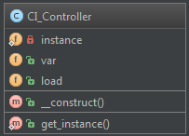 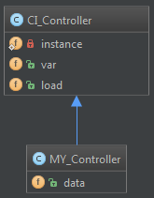

### Model-View-Controller (MVC) Pattern

Pictured below is an example usage of a **Model-View-Controller pattern**. The controller (Verfiy_Login) hears out requests and sends out a response and validates input for the View (LoginView). The controller alerts the model (Users) of changes in state that needs to be stored in the database.

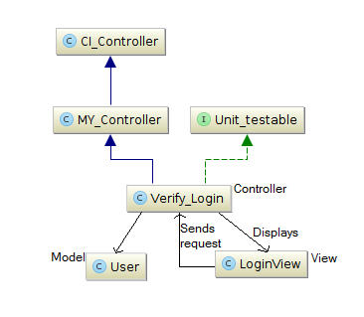



### Active Record Pattern

The CodeIgniter PHP web application framework implements a variation of the active record pattern. The Film Club CMS extends this design to fit with the needs of the modules/classes of the system.

The active record pattern is a pattern that seeks to achieve storage of temporary object data as data stored in relational database management systems.

Pictured below is the Film Club’s implementation of the active record pattern. Each model class is a representation of the table located within the MySQL database.

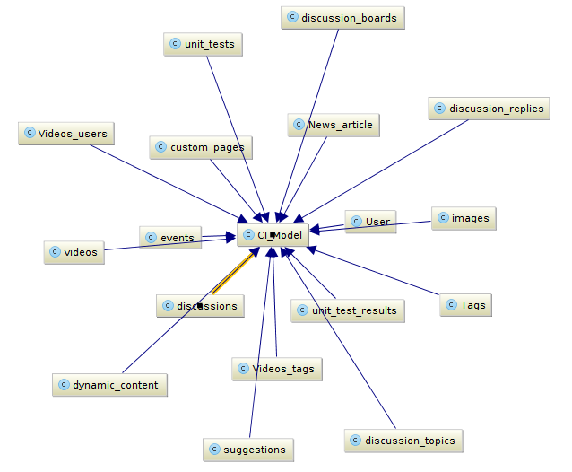

## Object Interaction

Pictured below are examples of a **model-view-controller (MVC)** sequence within the execution of the Film Club CMS. Notice the name of the model class reflects the database table (**active record pattern**).

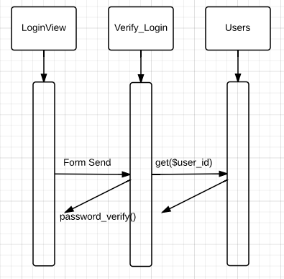

Sequence diagram of an actor posting a discussion to the discussion page.

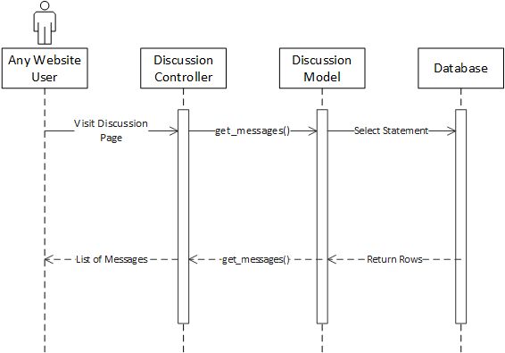

## Detailed Class Design

The purpose of each class referenced in the class diagrams in Appendix D can be found in the phpdoc.

# Testing Process

This section aims to elaborate on the SQA Plan in place for the Georgia Southern Film Club CMS.

## Software Quality Assurance Plan

### Purpose

The SQA plan in place aims to guarantee the quality of the system. Using additional software testing tools, a detailed and complete plan will ensure an optimal system.

### Reference Documents

### SQA Team Organization

*Lamar Sims*: **Test Team Leader**

* Generate Test Plan and organize documentation.
* Assign test cases to test analyst.
* Conveying issues to development team.
  + Assisting development team with such issues.
* Test all functionality thoroughly.
  + This involves the selenium IDE testing tool.
* Assist test analyst.
* Maintaining and organizing all testing documentation.

*Matthew Stratton*: **Test Team Analyst**

* Assist the test team leader in generating a test plan and creating documentation.
* Define the testing requirements.
* Designing the format of the test cases in section 7.2.
* Carrying out test cases and testing for expected results.
  + This involves the selenium IDE testing tool.
* Relaying test findings to test team leader and development team.
  + Assisting development team with such issues.

### Required Software and Hardware

* Selenium IDE (Firefox add-on)
* Mozilla Firefox
* MS Word 2010

## System Tests

Each system test will aim to ensure the quality of each functional aspect of the Georgia Southern Film Club CMS. These tests will involve taking each aspect of what the system shall do and comparing the actual results with the expected results. This will ensure that the users of the GSU Film Club CMS do not experience any failures or unexpected behavior.

|  |
| --- |
| TC_001 – Registering a new User |
| Test 1:   * Pre-Requirements: The user must be on the website and not currently logged in. * Use Case Reference #4.1-2 * Description: Test to see if the system properly allows a new user to create an account. * Inputs for input fields:   + 'Username': usertest20   + 'Email': ohioborn1991@yahoo.com   + 'First Name': Greg   + 'Last Name': Allman   + 'Password': greenCity   + 'Confirm': greenCity4 * Test Steps:  1. From any page on the website, click on the 'Register' button in the top right corner. 2. Enter all user information as listed in the specified inputs above. 3. Click 'Register'.  * Expected Output: The registration page will re-open with a message indicating that the account has been created, and prompts the user to 'Sign In'.   Test 2:   * Pre-Requirements: The user must be on the website and not currently logged in. * Use Case Reference #4.1-2 * Description: Test to see if the system properly detects an account that has been created with the same email or username. * Inputs for input fields:   + 'Username': usertest20   + 'Email': ohioborn1991@yahoo.com   + 'First Name': Timmy   + 'Last Name': Turner   + 'Password': greenCity4   + 'Confirm': greenCity4 * Test Steps:  1. From any page on the website, click on the 'Register' button in the top right corner. 2. Enter all user information as listed in the specified inputs above. 3. Click 'Register'.  * Expected Output: The registration page will re-open with a message indicating that an account exists with the same username or email.   Test 3:   * Pre-Requirements: The user must be on the website and not currently logged in. * Use Case Reference #4.1-2 * Description: Test to see if the system properly detects when user information is left out while registering, as all information is required. * Inputs for input fields:   + 'Username': (empty)   + 'Email': email24@gmail.com   + 'First Name': Timmy   + 'Last Name': (empty)   + 'Password': greenCity4   + 'Confirm': greenCity4 * Test Steps:  1. From any page on the website, click on the 'Register' button in the top right corner. 2. Enter all user information as listed in the specified inputs above. 3. Click 'Register'  * Expected Output: The registration page will re-open with a message indicating what fields were left out. In this case, Username and Last Name |

|  |
| --- |
| TC_002 – User Login |
| Test 1:   * Pre-Requirements: The user must be on the website and not currently logged in. * Use Case Reference #4.1-3 * Description: Test to see if the system allows users to log in to their created accounts upon entering the correct information. * Inputs for input fields:   + 'Email': ohioborn1991@yahoo.com   + 'Password': greenCity4 * Test Steps:  1. From any page on the website, navigate the cursor to the textbox that says 'Email' in the top right of the webpage. 2. Enter the 'Email' information as listed in the specified inputs above. 3. Tab over to the 'Password' textbox and enter the 'Password' information as listed in the specified inputs above. 4. Click 'Sign In'.  * Expected Output: The homepage will reload and you will see a 'Logged in as: 'Username'' in the top right. The user has successfully logged in.   Test 2:   * Pre-Requirements: The user must be on the website and not currently logged in. * Use Case Reference #4.1-3 * Description: Test to see if the system catches when an incorrect password has been entered for a user account. * Inputs for input fields:   + 'Email': ohioborn1991@yahoo.com   + 'Password': notcorrect2 * Test Steps:  1. From any page on the website, navigate the cursor to the textbox that says 'Email' in the top right of the webpage. 2. Enter the 'Email' information as listed in the specified inputs above. 3. Tab over to the 'Password' textbox and enter the 'Password' information as listed in the specified inputs above. 4. Click 'Sign In'.  * Expected Output: An incorrect password or email notification appears   Test 3:   * Pre-Requirements: The user must be on the website. * Use Case Reference #4.1-3 * Description: Test to see if the system catches when login information is left blank. * Inputs for input fields:   + 'Email': (empty)   + 'Password': (empty) * Test Steps:  1. From any page on the website, navigate to the button in the top right corner of the web page, 'Register'. 2. Leave both the 'Username' and 'Password' text boxes empty and click 'Sign In'.  * Expected Output: Prompt the user to enter a email and password. |

|  |
| --- |
| TC_003 – User Log Out |
| Test 1:   * Pre-Requirements: The user must be on the website and currently logged in. * Use Case Reference #4.1-4 * Description: Test to see if the system properly logs out a currently logged in user. * Inputs for input fields: (NONE) * Test Steps:  1. Navigate to the top right of the webpage and find the option to 'Sign Out'. 2. Click 'Sign Out'.  * Expected Output: The webpage is redirected to the home page, and the fields as referenced in Test Case TC_002 are visible, indicating no user is logged in. |

|  |
| --- |
| TC_004 – Social Media Navigation |
| Test 1:   * Pre-Requirements: The user must be on the website. * Use Case Reference #4.1-5 * Description: Test to see if the system properly directs the user to the external YouTube page as related to the GSU Film Club. * Inputs for input fields: (NONE) * Test Steps:  1. Scroll to the bottom of the webpage. 2. Find the social media buttons under 'Follow Us'. 3. Click the first one that contains the YouTube logo.  * Expected Output: The web page will be redirected to the GSU Film Club's YouTube channel.   Test 2:   * Pre-Requirements: The user must be on the website. * Use Case Reference #4.1-5 * Description: Test to see if the system properly directs the user to the external Twitter page as related to the GSU Film Club. * Inputs for input fields: (NONE) * Test Steps:  1. Scroll to the bottom of the webpage. 2. Find the social media buttons under 'Follow Us'. 3. Click the second one that contains the Twitter logo.  * Expected Output: The web page will be redirected to the GSU Film Club's Twitter page.   Test 3:   * Pre-Requirements: The user must be on the website. * Use Case Reference #4.1-5 * Description: Test to see if the system properly directs the user to the external Facebook page as related to the GSU Film Club. * Inputs for input fields: (NONE) * Test Steps:  1. Scroll to the bottom of the webpage. 2. Find the social media buttons under 'Follow Us'. 3. Click the third one that contains the Facebook logo.  * Expected Output: The web page will be redirected to the GSU Film Club's Facebook page. |

|  |
| --- |
| TC_005 – Profile Image Creation & Replacement |
| Test 1:   * Pre-Requirements: The user must be on the website and logged on. * Use Case Reference #4.1-6 * Description: Test to see if the system allows a user to upload an image to use as their personal profile image. * Inputs for input fields:   + 'Choose a File': 'Browse' to select an image saved somewhere on the computer * Test Steps:  1. Navigate to the top right of the web page where it says 'Logged in as: 'Username', and click on the drop down arrow 2. Choose the first option, 'Your Profile'. 3. Scroll down to the panel listed as 'Manage Profile Picture'. 4. Under 'Add or Edit Profile Picture', click 'Browse'. 5. Navigate to where the desired png, jpg, or gif file is stored on the computer. 6. Press 'Open' and then 'Upload'.  * Expected Results: The users profile page will re-load and the new profile picture will be visible.   Test 2:   * Pre-Requirements: The user must be logged on and already has specified a profile image. * Use Case Reference #4.1-7 * Description: Test to see if the system allows a users profile image to be replaced with a new one. * Inputs for input fields:   + 'Choose a File': 'Browse' to select an image saved somewhere on the computer * Test Steps:  1. Navigate to the top right of the web page where it says 'Logged in as: 'Username', and click on the drop down arrow. 2. Choose the first option, 'Your Profile'. 3. Scroll down to the panel listed as 'Manage Profile Picture'. 4. Under 'Add or Edit Profile Picture', click 'Browse'. 5. Navigate to where the desired png, jpg, or gif file is stored on the computer. 6. Press 'Open' and then 'Upload'.  * Expected Results: The users profile page will re-load and the updated profile picture will be visible.   Test 3:   * Pre-Requirements: The user must be on the website and logged on. * Use Case Reference #4.1-6 & #4.1-7 * Description: Test to see if the system does not allow for non image type files to be used as a profile picture. * Inputs for input fields:   + 'Choose a File': 'Browse' to select a non image type file stored somewhere on the computer. * Test Steps:  1. Navigate to the top right of the web page where it says 'Logged in as: 'Username', and click on the drop down arrow. 2. Choose the first option, 'Your Profile'. 3. Scroll down to the panel listed as 'Manage Profile Picture'. 4. Under 'Add or Edit Profile Picture', click 'Browse'. 5. Navigate to where a non image file such as a docx, txt, mp3, is stored on the computer. 6. Press 'Open' and then 'Upload'.  * Expected Results: The users profile page will re-load with an error regarding the file format of the image selected. |

|  |
| --- |
| TC_006 – Profile Image Deletion |
| Test 1:   * Pre-Requirements: The user must be on the website and logged in & must have a profile picture for their personal account. * Use Case Reference #4.1-8 * Description: Test to see if the system properly allows a user to remove their pre-existing profile picture from their account. * Inputs for input fields: (none) * Test Steps:  1. Navigate to the 'Your Profile' page. (See steps 1 - 2 in TC_005, Test 1). 2. In the manage profile picture panel, look for 'Delete Profile Picture' 3. Click 'Delete'  * Expected Results: The users profile picture will be removed and replaced with the default empty profile picture view.   Test 2:   * Pre-Requirements: The user must be on the website and logged in & must not have a profile picture for their personal account. * Use Case Reference #4.1-8 * Description: Test to see if the system properly allows catches when a user tries to delete a profile picture from their account when one does not exist * Inputs for input fields: (none) * Test Steps:  1. Navigate to the 'Your Profile' page. (See steps 1 - 2 in TC_006, Test 1). 2. In the manage profile picture panel, look for 'Delete Profile Picture'. 3. Click 'Delete'.  * Expected Results: The system will display an error saying that a profile picture does not exist. |

|  |
| --- |
| TC_007 – Reply to Discussion Thread |
| Test 1:   * Pre-Requirements: The user must be on the Discussion page, and has at least Club Member account level. * Use Case Reference #4.1-10 * Description: Test to see if the system allows a user to respond to a currently existing discussion thread. * Inputs for input fields:   + Desired reply text in the 'Message' text box. * Test Steps:  1. On the discussion page, find a currently existing thread to reply to 2. On the right side of the thread, click the button titled 'Reply'. 3. Fill in desired reply in the text area of the 'Message' text box. 4. Click 'Submit'.  * Expected Results:The discussion page will reload with the new comment under the desired thread.   Test 2:   * Pre-Requirements: The user must be on the Discussion page, and has at least Club Member account level. * Use Case Reference #4.1-10 * Description: Test to see if the system allows a user to respond with an empty response to a currently existing thread. * Inputs for input fields:   + Empty reply text in the 'Message' text box. * Test Steps:  1. On the discussion page, find a currently existing thread to reply to 2. On the right side of the thread, click the button titled 'Reply'. 3. Click 'Submit'.  * Expected Results:The discussion page will reload with the error sayintg that the message field is required.   Test 3:   * Pre-Requirements: The user must be on the Discussion page, and has at least Club Member account level. * Use Case Reference #4.1-10 * Description: Test to see if the system allows a user to respond to a currently existing discussion thread and include an image. * Inputs for input fields:   + Desired reply text in the 'Message' text box.   + 'Source' and 'Image Description' when adding image. * Test Steps:  1. On the discussion page, find a currently existing thread to reply to 2. On the right side of the thread, click the button titles 'Reply'. 3. Enter desired text into the text box. 4. Click 'Insert'. 5. Click 'Insert/edit image'. 6. Copy the file path for where the image is found on the computer.\ 7. Paste it into the 'Source' field. 8. Give it an image description in the 'Image Description' field. 9. Unclick the check box that says 'Constrain Properties'. 10. Click 'OK'  * Expected Results:The discussion page will reload with the new comment & image under the thread.   Test 4:   * Pre-Requirements: The user must be on the Discussion page,and has at least Club Member account level. * Use Case Reference #4.1-10 * Description: Test to see if the system allows a user to respond to a currently existing discussion thread and include a video. * Inputs for input fields:   + Desired reply text in the 'Message' text box.   + Embed code for link of the video * Test Steps:  1. On the discussion page, find a currently existing thread to reply to 2. On the right side of the thread, click the button titles 'Reply'. 3. Enter desired text into the text box. 4. Click 'Insert'. 5. Click 'Insert/edit video'. 6. Click on the 'Embed' tab. 7. Paste it into the provided text field. 8. Click 'OK'  * Expected Results:The discussion page will reload with the new comment & video under the thread. |

|  |
| --- |
| TC_008 – Calendar Event Creation |
| Test 1:   * Pre-Requirements: User must be logged in and have administrator privileges. * Use Case Reference #4.1-11 * Description: Test the system to see if it correctly allows a new event to be created for a proper date * Inputs for input fields:   + 'Event Name'   + 'Date'   + 'Time'   + 'Location'   + 'Event Description' * Test Steps:  1. At the top navigation bar, click 'Events'. 2. Click 'Event Submission' found at the top of the calendar. 3. Input all required fields above ( for 'Date' enter 05/20/2015 ). 4. Click 'Submit'.  * Expected Results: The event creation page will reload and notify the administrator user that the event has been submitted. The event can now be found on the calendar.   Test 2:   * Pre-Requirements: User must be logged in and not have administrator privileges. * Use Case Reference #4.1-11 * Description: Test the system to see if it does not allow for a non administrator to post new events. This feature is available only to admins. * Inputs for input fields:   + 'Event Name'   + 'Date'   + 'Time'   + 'Location'   + 'Event Description' * Test Steps:  1. At the top navigation bar, click 'Events'. 2. Click 'Event Submission' found at the top of the calendar. 3. Input all required fields above ( for 'Date' enter 05/21/2015 ). 4. Click 'Submit'.  * Expected Results: The event creation page will reload and notify the user that the event has been submitted.   Test 3:   * Pre-Requirements: User must be logged in at any account level. * Use Case Reference #4.1-11 * Description: Test the system to see if it correctly allows for multiple events to be created on the same date. * Inputs for input fields:   + 'Event Name'   + 'Date'   + 'Time'   + 'Location'   + 'Event Description' * Test Steps:  1. At the top navigation bar, click 'Events'. 2. Click 'Event Submission' found at the top of the calendar. 3. Input all required fields above ( for 'Date' enter 05/20/2015 ). 4. Click 'Submit'.  * Expected Results: The event creation page will reload and notify the user that the event has been submitted. The event will be listed under the event created from TC_009 Test 1. |

|  |
| --- |
| TC_009 – Event Modification **NYI |
| * Pre-Requirements: The user must be on the website and not currently logged in. * Use Case Reference #4.1-12 * Description: Test to see if the system properly allows a user to sign in to their account. * Test Plan:  1. Sign in to a test account that has been created using correct credentials. 2. Sign in to a test account that has been created using caps lock. 3. Sign in to a test account that has been created using an incorrect password. 4. Sign in to an account that does not exist. |

|  |
| --- |
| TC_010 – Event Deletion **NYI |
| * Pre-Requirements: The user must be logged in as an admin and on the event page. * Use Case Reference #4.1-13 * Description: Test to see if an event created on the calander is allowed to be deleted. * Inputs for input fields: (none) * Test Steps:  1. On the Events page, find the event listed in the calendar that is to be deleted. 2. Click the event link 3. Click 'Delete Event' in the upper right hand corner. 4. A Confirmation dialog box will appear. Click 'Delete'.  * Expected Results: The event page will reload with a confirmation that the event has been deleted. |

|  |
| --- |
| TC_011 – Calender Navigation |
| Test 1:   * Pre-Requirements: The user must be on the website and logged in.The user must currently be on the Events page. * Use Case Reference #4.1-14 * Description: Test to see if the system allows for any user to browse through the events listed by month. * Inputs for input fields: (none) * Test Steps:  1. On the Events page, locate the arrows next to the current month 2. Click the arrow to the right of the month twice. 3. Click the arrow to the left of the month 4 times. 4. Click the arrow to the right of the month 6 times.  * Expected Output: The user can properly navigate to any month they desire. |

|  |
| --- |
| TC_012 – Custom Page Creation |
| Test 1:   * Pre-Requirements: Must be logged in as an administrator and on the 'Dashboard' page. * Use Case Reference #4.1-15 * Description: Test the creation of a custom page for the website * Inputs for input fields:   + 'Title': Test Title   + 'Body Content': This is the body of the test for the Body Content. * Test Steps:  1. Click on the 'Custom Pages' button, on the left side of the page. Takes user to the 'Manage Custom Pages' page. 2. Then click the 'Create New Page' button, at the top of the page. Takes user to the 'Create Custom Page' page. 3. On the 'Create Custom Page' page, use the specified inputs for the 'Title' field and the 'Body Content' field. 4. Click on the 'Submit' button, on the bottom of the page, to create the new custom page.  * Expected Output: At the top of the 'Create Custom Page' page a green notification panel displays 'Your page was successfully created!'. On the 'Manage Custom Pages' page your created custom page should be at the bottom of the listed custom pages with your username.   Test 2:   * Pre-Requirements: Must be logged in as an administrator and on the 'Dashboard' page. * Use Case Reference #4.1-15 * Description: Test the creation of a custom page for the website * Inputs for input fields:   + 'Title': Test for embedding videos   + 'Body Content': <iframe width="560" height="315" src="https://www.youtube.com/embed/h2shopQ3owY" frameborder="0" allowfullscreen></iframe> * Test Steps:  1. Click on the 'Custom Pages' button, on the left side of the page. Takes user to the 'Manage Custom Pages' page. 2. Then click the 'Create New Page' button, at the top of the page. Takes user to the 'Create Custom Page' page. 3. On the 'Create Custom Page' page, use the specified input for the 'Title' field. For the 'Body Content' field, on the toolbar click on 'Insert', which will bring up a drop down of options. Click on 'Insert/edit video' to bring up the input box. Click on the 'Embed' tab and insert the specified input, for the 'Body Content', for Test 2. Click the 'Ok' button. 4. Click on the 'Submit' button, on the bottom of the page, to create the new custom page.  * Expected Output: At the top of the 'Create Custom Page' page a green notification panel displays 'Your page was successfully created!'. On the 'Manage Custom Pages' page your created custom page should be at the bottom of the listed custom pages with your username.   Test 3:   * Pre-Requirements: Must be logged in as an administrator and on the 'Dashboard' page. * Use Case Reference #4.1-15 * Description: Test the creation of a custom page for the website * Inputs for input fields:   + 'Title':   + 'Body Content': * Test Steps:  1. Click on the 'Custom Pages' button, on the left side of the page. Takes user to the 'Manage Custom Pages' page. 2. Then click the 'Create New Page' button, at the top of the page. Takes user to the 'Create Custom Page' page. 3. On the 'Create Custom Page' page, leave the 'Title' field and the 'Body Content' field empty. 4. Click on the 'Submit' button, on the bottom of the page, to create the new custom page.  * Expected Output: At the top of the 'Create Custom Page' page a red notification panel displays 'The Title field is required.' and 'The Body Text field is required.'. |

|  |
| --- |
| TC_013 – Custom Page Modification |
| Test 1:   * Pre-Requirements: See TC_014 Pre-Reqs. A page must exist to modify. * Use Case Reference #4.1-16 * Description: Testing the editing of already existing custom pages * Input for input fields:   + 'Title': New Test Title   + 'Body Content': This is the Edit for the body of the test for the Body Content. * Test Steps:  1. Click on the 'Custom Pages' button, on the left side of the page. Takes user to the 'Manage Custom Pages' page. 2. Search for the existing custom page to be modified and then click the 'Edit' button. 3. On the 'Edit Custom Page' enter the specified inputs for the 'Title' field and for the 'Body Content' field. 4. Click the 'Submit' button, on the bottom of the page, to finalize the edit for the custom page.  * Expected Output: At the top of the 'Create Custom Page' page a green notification panel displays 'Your page was successfully modified!'. On the 'Manage Custom Pages' page your modified custom page should be in the same position as before, of the listed custom pages, with the modified title and time it was modified.   Test 2:   * Pre-Requirements: See TC_014 Pre-Reqs. A page must exist to modify. * Use Case Reference #4.1-16 * Description: Testing the editing of already existing custom pages * Input for input fields:   + 'Title':   + 'Body Content': * Test Steps:  1. Click on the 'Custom Pages' button, on the left side of the page. Takes user to the 'Manage Custom Pages' page. 2. Search for the existing custom page to be modified and then click the 'Edit' button. 3. On the 'Edit Custom Page' do not change the current inputs for the 'Title' field and for the 'Body Content' field. 4. Click the 'Submit' button, on the bottom of the page, to finalize the edit for the custom page.  * Expected Output: At the top of the 'Create Custom Page' page a green notification panel displays 'Your page was successfully modified!'. On the 'Manage Custom Pages' page your modified custom page should be in the same position as before, of the listed custom pages, with the modified title and time it was modified.   Test 3:   * Pre-Requirements: See TC_014 Pre-Reqs. A page must exist to modify. * Use Case Reference #4.1-16 * Description: Testing the editing of already existing custom pages * Input for input fields:   + 'Title':   + 'Body Content': * Test Steps:  1. Click on the 'Custom Pages' button, on the left side of the page. Takes user to the 'Manage Custom Pages' page. 2. Search for the existing custom page to be modified and then click the 'Edit' button. 3. On the 'Edit Custom Page' delete the current inputs for the 'Title' field and for the 'Body Content' field and do not enter any new information for either field. 4. Click the 'Submit' button, on the bottom of the page, to finalize the edit for the custom page.  * Expected Output: At the top of the 'Create Custom Page' page a red notification panel displays 'The Title field is required.' and 'The Body Text field is required.'. |

|  |
| --- |
| TC_014 – Custom Page Deletion |
| Test 1:   * Pre-Requirements: See TC_014 Pre-Reqs. A page must exist to delete. * Use Case Reference #4.1-17 * Description: Testing the deletion of created custom pages * Test Steps:  1. Click on the 'Custom Page' button, on the left side of the page. Takes user to the 'Manage Custom Pages' page. 2. Search for the existing custom page to be modified and then click the 'Delete' button, bringing up an alert for deletion confirmation. 3. Click the 'Yes, delete the page' button.  * Expected Output: On the top of the 'Manage Custom Pages' page a green notification panel displays 'Custom Page was successfully deleted', and the custom page is no longer displayed on the 'Manage Custom Pages' page.   Test 2:   * Pre-Requirements: See TC_014 Pre-Reqs. A page must exist to delete. * Use Case Reference #4.1-17 * Description: Testing the deletion of created custom pages * Test Steps:  1. Click on the 'Custom Page' button, on the left side of the page. Takes user to the 'Manage Custom Pages' page. 2. Search for the existing custom page to be modified and then click the 'Delete' button, bringing up an alert for deletion confirmation. 3. Click the 'No, do not delete' button.  * Expected Output: Takes user back to the 'Manage Custom Pages' page with the custom page still being displayed. |

|  |
| --- |
| TC_015 – Administrator Reads Messages |
| Test 1:   * Pre-Requirements: Must be logged in as an administrator. * Use Case Reference #4.1-18 * Description: Test the reading of messages and/or suggestions to sent to the Film Club. * Test Steps:  1. On the toolbar, from the top of any page, click your username to bring down an option drop down menu. 2. In the drop down menu, click the 'Dashboard'.  * Expected Output: Takes user to the 'Dashboard' page where the messages are displayed in the body of the page to be read. |

|  |
| --- |
| TC_016 – Administrator Suspends User |
| Test 1:   * Pre-Requirements: Must be logged in as administrator and on the 'Dashboard' page. User accounts must exist to be suspended. * Use Case Reference #4.1-19 * Description: Testing the activity of an administrator to be able to suspend a registered account. * Test Steps:  1. Click on the 'Manage Users' button, on the left of the 'Dashboard' page. Takes user to 'User Management' page. 2. Current user accounts will appear on the body of the page. Find the user whose account is to be suspended. 3. In the row, for the user to be suspended, at the far right column there will be three buttons. Click on the red 'Suspend' button.  * Expected Output: 'User Management' page will be refreshed. Find the user, whose account was suspended, and in there 'Type' column it will be blank where their previous title/rank was displayed. |

|  |
| --- |
| TC_017 – Administrator Promotes User |
| Test 1:   * Pre-Requirements: Must be logged in as administrator and on the 'Dashboard' page. User accounts must exist to be suspended. * Use Case Reference #4.1-20 * Description: Testing the activity of an administrator to be able to promote a registered account. * Test Steps:  1. Click on the 'Manage Users' button, on the left of the 'Dashboard' page. Takes user to 'User Management' page. 2. Current user accounts will appear on the body of the page. Find the user whose account is to be promoted. 3. In the row, for the user to be promoted, at the far right column there will be three buttons. Click on the green 'Promote' button.  * Expected Output: 'User Management' page will be refreshed. Find the user, whose account was promoted, and in there 'Type' column there will be a new title/rank than before, indicating the user has been promoted.   Test 2:   * Pre-Requirements: Must be logged in as administrator and on the 'Dashboard' page. User accounts must exist to be suspended. * Use Case Reference #4.1-20 * Description: Suspends the user's account and then promotes into to active again. * Test Steps:  1. Execute TC_016: Test 1. 2. Find the account that TC_017: Test 1 was executed on. In the row, for the user to be promoted, at the far right column there will be three buttons. Click on the green 'Promote' button.Expected Output: 'User Management' page will be refreshed. Find the user, whose account was promoted, and in there 'Type' column the previous title/rank, before suspension, will reappear showing that the account is now active, not suspended, again. |

|  |
| --- |
| TC_018 – Administrator adds Videos |
| Test 1:   * Pre-Requirements: Must be logged in as administrator and on the 'Dashboard' page. * Use Case Reference #4.1-21 * Description: Adds an embedded video to the site's 'Browse Videos' page. * Inputs:   + YouTube ID: 6TIl_qW8Mts   + Tags: Select Cool Tag   + Site Description: Test Video: Unreal Tournament * Test Steps:  1. Click on the 'Videos' button, on the left of the 'Dashboard' page. Takes user to 'Add Videos' page. 2. Enter in the specified inputs for the 'YouTube ID' field, 'Tags' selection, and 'Site Description' field. 3. At the bottom of the 'Add Videos' page click the 'Submit' button.  * Expected Output: At the top of the 'Add Videos' page a green panel displays, 'You have successfully added the video!'. On the 'Browse Videos' page the submitted video will be displayed.   Test 2:   * Pre-Requirements: Must be logged in as administrator and on the 'Dashboard' page. * Use Case Reference #4.1-21 * Description: Adds an embedded video to the site's 'Browse Videos' page. * Inputs:   + YouTube ID: LlRei0KMP1g   + Tags:   + Site Description: Test Video: AMV Anime Fight * Test Steps:  1. Click on the 'Videos' button, on the left of the 'Dashboard' page. Takes user to 'Add Videos' page. 2. Enter in the specified inputs for the 'YouTube ID' field and 'Site Description' field. 3. At the bottom of the 'Add Videos' page click the 'Submit' button.  * Expected Output: At the top of the 'Add Videos' page a green panel displays, 'You have successfully added the video!'. On the 'Browse Videos' page the submitted video will be displayed with the selected 'Site Description'.   Test 3:   * Pre-Requirements: Must be logged in as administrator and on the 'Dashboard' page. * Use Case Reference #4.1-21 * Description: Attempts to an embedded video to the site's 'Browse Videos' page, without using inputs. * Inputs:   + YouTube ID:   + Tags:   + Site Description: * Test Steps:  1. Click on the 'Videos' button, on the left of the 'Dashboard' page. Takes user to 'Add Videos' page. 2. Leave the 'YouTube ID' field and 'Site Description' field empty. 3. At the bottom of the 'Add Videos' page click the 'Submit' button.  * Expected Output: At the top of the 'Add Videos' page a red panel displays, 'The YouTube ID field is required.' and 'The Site Description field is required.'. |

|  |
| --- |
| TC_019 – Administrator adds Images |
| Test 1:   * Pre-Requirements: Must be signed in as administrator. * Use Case Reference #4.1-22 * Description: Test the uploading of images to the websites 'Browse Our Gallery' page. * Test Steps:  1. From the top of any website page click on the 'Media' tab to open a drop-down menu. 2. Click on the first option in the drop-down menu, 'Pictures'. Takes user to 'Browse Our Gallery' page. 3. Click on the 'Add Photos' button. Will take user to 'File Upload' page. 4. Click the 'Choose File' button. Will open up a File Dialog, navigate to the folder to the photo to be uploaded. Click the file, then click the 'Open' button on the File Dialog. 5. Click the 'Upload' button, at the bottom of the 'File Upload' page.  * Expected Result: At the top of the 'File Upload' page will be a green panel saying, 'Your file was successfully uploaded!'. Uploaded picture will now be displayed in the 'Browse Our Gallery' page. |

|  |
| --- |
| TC_020 – User Creates Request or Suggestion |
| Test 1:   * Pre-Requirements: Currently on the website. * Use Case Reference #4.1-23 * Description: Create a Suggestion message to send to the Film Club. * Inputs:   + First Name: Bob   + Last Name: Bobby   + Email: Bob@email.com   + Phone: 1234567   + Subject: Test Suggestion   + Message: We would like to test suggestion messages. * Test Steps:  1. From the top of any website page click on the 'About' tab to open a drop-down menu. 2. Click on the fourth option in the drop-down menu, 'Suggestions'. Takes user to 'Suggestions' page. 3. Enter in the specified inputs for 'First Name', 'Last Name', 'Email', 'Phone', 'Subject', and 'Message'. 4. At the bottom of the page click the 'Submit' button.  * Expected Output: 'Suggestions' page refreshes. At the top of the page a green panel says 'Thank you! Your suggestion was successfully submitted. We may contact you soon.'   Test 2:   * Pre-Requirements: Currently on the website. * Use Case Reference #4.1-23 * Description: Create a blank Suggestion message to send to the Film Club. * Inputs:   + First Name:   + Last Name:   + Email:   + Phone:   + Subject:   + Message: * Test Steps:  1. From the top of any website page click on the 'About' tab to open a drop-down menu. 2. Click on the fourth option in the drop-down menu, 'Suggestions'. Takes user to 'Suggestions' page. 3. Leave the 'First Name', 'Last Name', 'Email', 'Phone', 'Subject', and 'Message' fields empty. 4. At the bottom of the page click the 'Submit' button.  * Expected Output: 'Suggestions' page refreshes. At the top of the page a red panel says, 'The First Name field is required;, 'The Last name field is required', 'The Email field is required', 'The Phone field is required', 'The Subject field is required', and 'The Message field is required'. |

|  |
| --- |
| TC_021 – User Changes Template |
| * ************************************** * Pre-Requirements: The user must be on the website and not currently logged in. * Use Case Reference #4.1-3 * Description: Test to see if the system properly allows a user to sign in to their account. * Test Plan:  1. Sign in to a test account that has been created using correct credentials. 2. Sign in to a test account that has been created using caps lock. 3. Sign in to a test account that has been created using an incorrect password. 4. Sign in to an account that does not exist. |

|  |
| --- |
| TC_022 – User Profile Modification |
| * *************************************** * Pre-Requirements: The user must be on the website and not currently logged in. * Use Case Reference #4.1-3 * Description: Test to see if the system properly allows a user to sign in to their account. * Test Plan:  1. Sign in to a test account that has been created using correct credentials. 2. Sign in to a test account that has been created using caps lock. 3. Sign in to a test account that has been created using an incorrect password. 4. Sign in to an account that does not exist. |

|  |
| --- |
| TC_023 – Contact Information Retrieval |
| Test 1:   * Pre-Requirements: The user must be on the website. * Use Case Reference #4.1-26 * Description: Retrieves the Film Club's contact information. * Test Steps:  1. From the top of any website page click on the 'About' tab to open a drop-down menu. 2. Click on the third option in the drop-down menu, 'Contact'. Takes user to Contact Information' page.  * Expected Output: User is on the 'Contact Information' page, with the contact information displayed on the body of the page. |

|  |
| --- |
| TC_024 – Contact Information Modification |
| Test 1:   * Pre-Requirements: Must be logged in as administrator and on the 'Dashboard' page. * Use Case Reference #4.1-27 * Description: Change the contact information for the GSU Film Club. * Input: This is a test for contact information modification. P.O. Box 5555 Statesboro, GA 30460 * Test Steps:  1. On the left of the 'Dashboard' page click the 'Site Information' button. Takes user to 'Site Information' page. 2. At the bottom of the 'Site Information' page, will be the 'Contact Us' dialog box. Copy the specified input into the bottom of the 'Contact Us' dialog box. 3. At the bottom of the 'Contact Us' dialog box click the 'Submit Changes' button;  * Expected Output: At the top of the 'Site Information' page will be a green panel saying, 'Your page was successfully modified!'. The 'Contact Us' dialog box should now have the specified information in it.   Test 2:   * Pre-Requirements: Must be logged in as administrator and on the 'Dashboard' page. * Use Case Reference #4.1-27 * Description: Submit a change for the contact information without changing anything. * Input: * Test Steps:  1. On the left of the 'Dashboard' page click the 'Site Information' button. Takes user to 'Site Information' page. 2. At the bottom of the 'Site Information' page, will be the 'Contact Us' dialog box. Leave the current contact information in the 'Contact Us' dialog box. 3. At the bottom of the 'Contact Us' dialog box click the 'Submit Changes' button;  * Expected Output: At the top of the 'Site Information' page will be a green panel saying, 'Your page was successfully modified!'. |

## Subsystem Tests

### Introduction

The Subsystem Test tests our Login subsystem for the GSU Film Club's website. It deals with the verification and validation of the email and password specified to see if it matches the database's email and that email's password. It will also test if the user does not specify an email but a password, does not specify a password or email, and does not specify either password or email. It as well tests the Logout function for the website.

### Unit Tests

1. **Unit Test 1**

Test a valid login, with a member that is already registered in the website's DB.

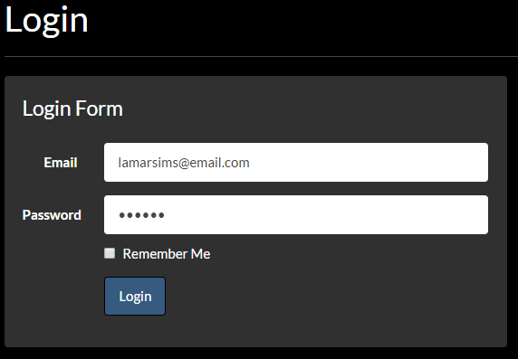

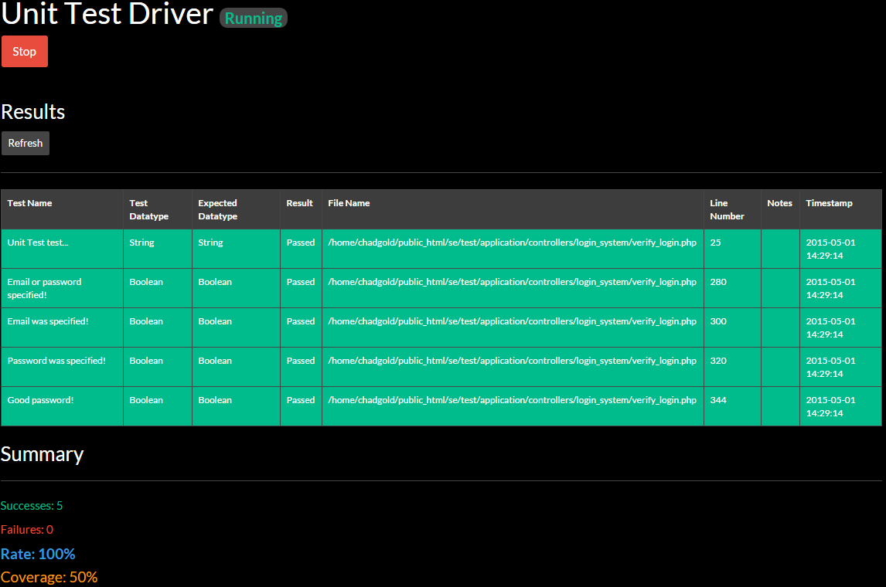

1. **Unit Test 2**

Test the Logout of a member.

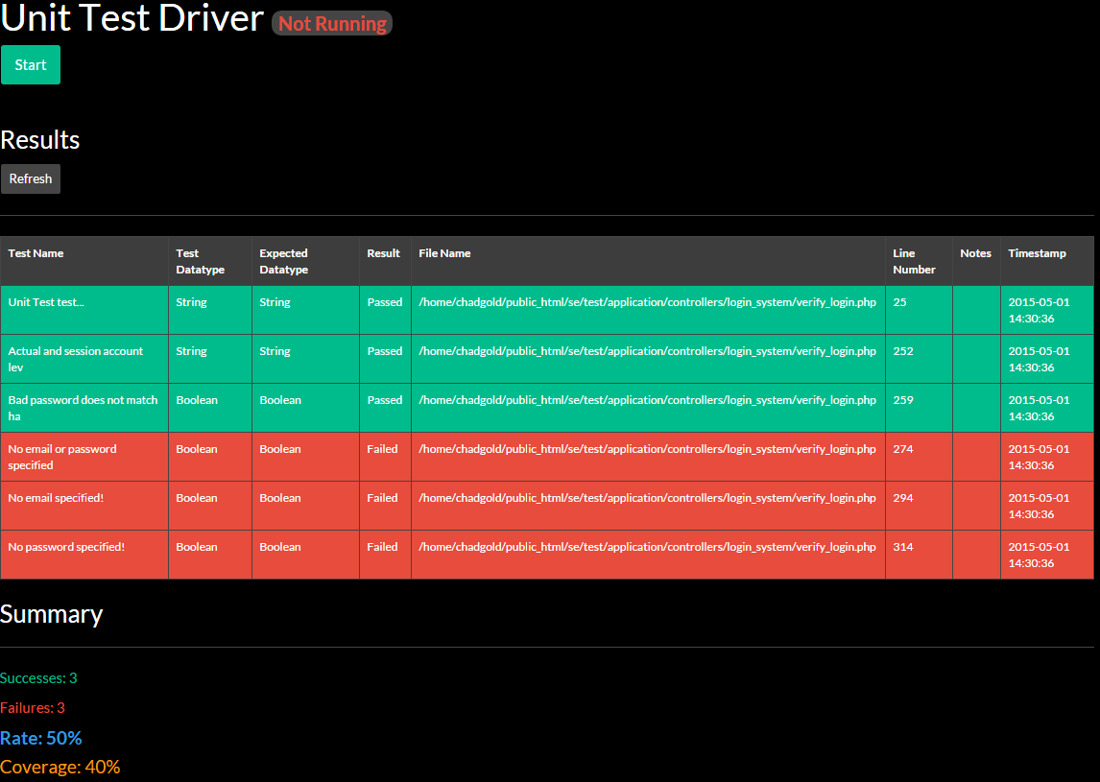

1. **Unit Test 3**

Test an invalid login where the email is valid and the password is not.

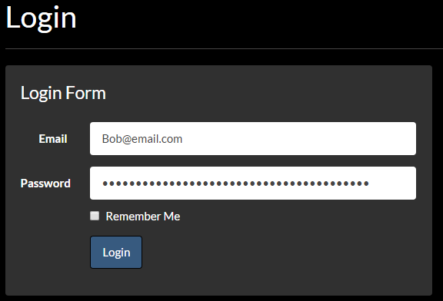

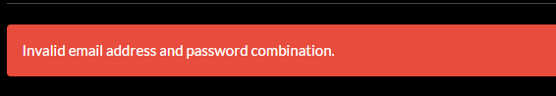

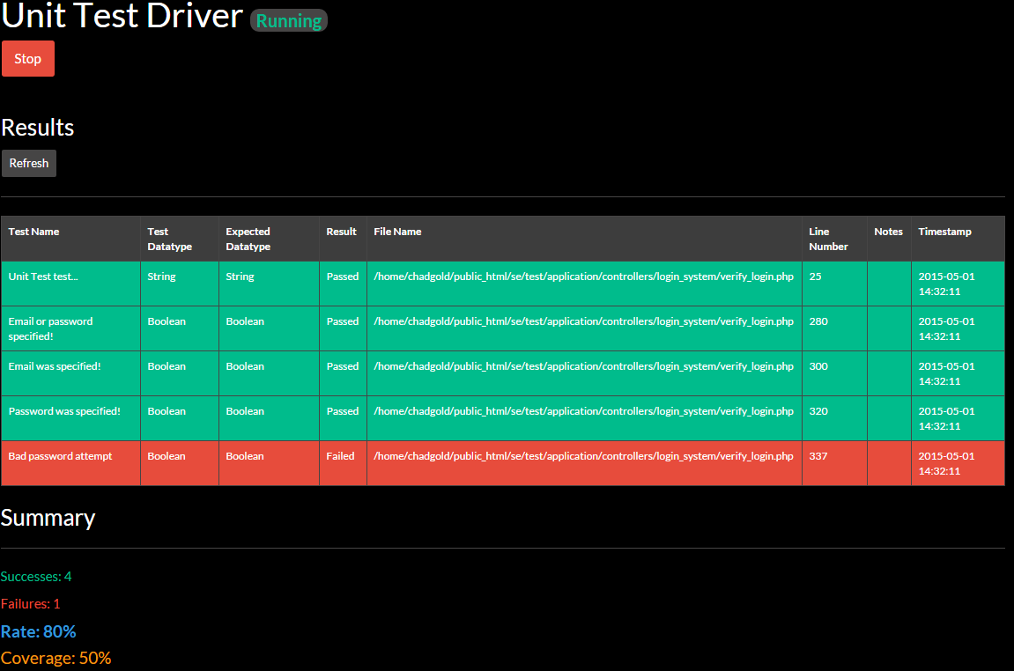

1. **Unit Test 4**

Tests invalid login where, no email is specified and password is specified.

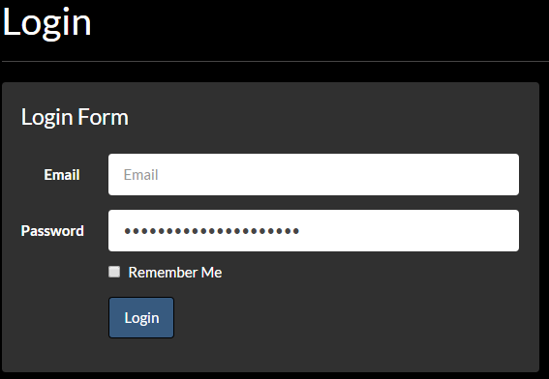



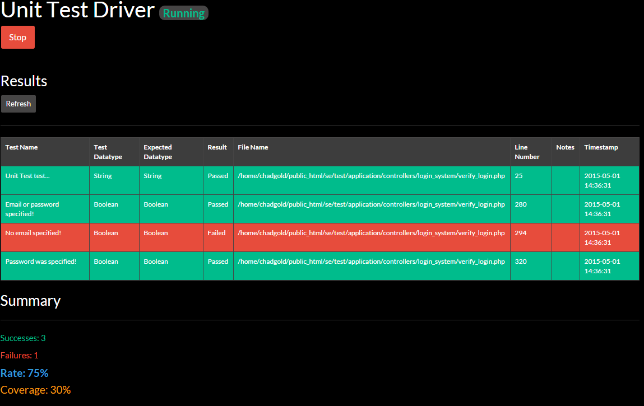

1. **Unit Test 5**

Test invalid login, where email is specified and password is not.

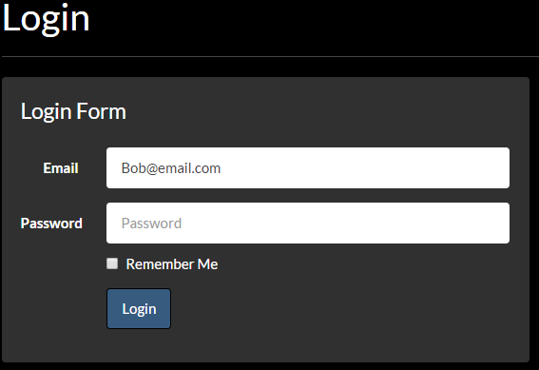



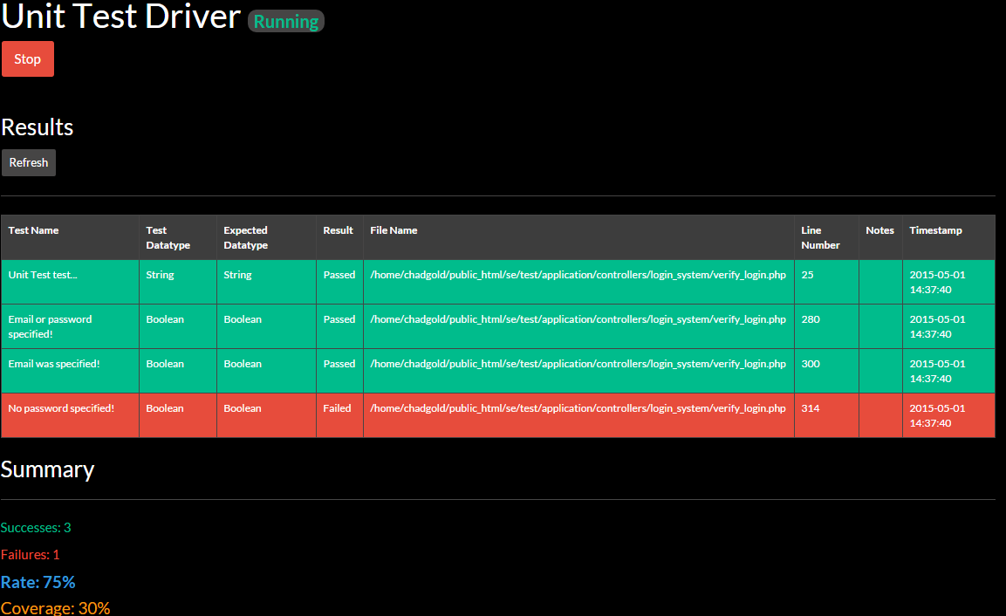

1. **Unit Test 6**

Test invalid login where neither email nor password is specified.

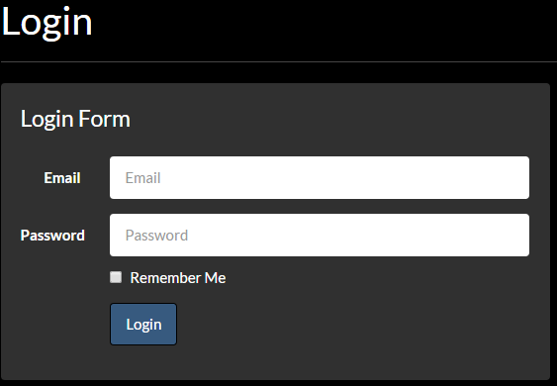



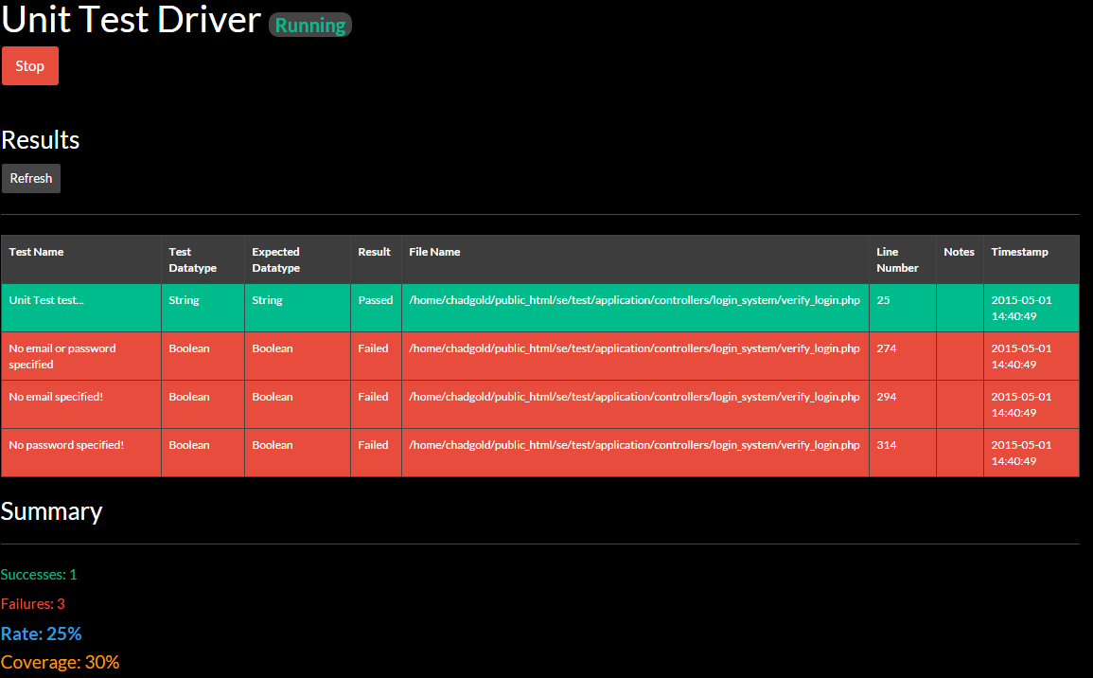

## Evaluation of Tests

|  |  |  |  |  |
| --- | --- | --- | --- | --- |
| Test Case ID | Actual Results | P/F | Intent | Actions to be taken |
| TC_001_Test1 | Same as Expected Result | P | Register new user | None |
| TC_001_Test2 | Same as Expected Result | P |  |  |
| TC_001_Test3 | Same as Expected Result | P |  |  |
| TC_002_Test1 | Same as Expected Result | P | Login to currently existitng account |  |
| TC_002_Test2 | 404 Page Not Found Error | F | Login to account with incorrect password | Error checking to check for incorrect login. |
| TC_002_Test3 | 404 Page Not Found Error | F | Login to without specifying email or password | Error checking to check for incorrect login. |
| TC_003_Test1 | Same as Expected Result | P | User logs out | None |
| TC_004_Test1 | Same as Expected Result | P | Use social media link to go to GSU Film Club YouTube page | None |
| TC_004_Test2 | Same as Expected Result | P | Use social media link to go to GSU Film Club Twitter page | None |
| TC_004_Test3 | Just takes to Facebook home page | F | Use social media link to go to GSU Film Club Facebook page | Fix linking error to link to GSU Film Club Facebook page |
| TC_005_Test1 | Same as Expected Result | P | Upload a profile picture | None |
| TC_005_Test2 | Same as Expected Result | P | Replace a previous profile picture | None |
| TC_005_Test3 | Page refreshed, and nothing happened | F | Catch trying to upload any file that was not a picture file | Add Error checking for uploading of incorrect file types. |
| TC_006_Test1 | Same as Expected Result | P | Delete a picture | None |
| TC_006_Test2 | Throws PHP error | F | Delete a profile picture when there is not one there | Add Error checking for deleting profile pictures |
| TC_007_Test1 | Same as Expected Result | P | Reply to an existing discussion thread | None |
| TC_007_Test2 | Same as Expected Result | P | Was to get error message if the 'Message' field was left empty | None |
| TC_007_Test3 | Reply displayed without the picture | F | Was to reply to a discussion thread with an embedded picture | Implement a file dialog to be able to choose a picture to embedded in the reply |
| TC_007_Test4 | Same as Expected Result | P | Reply to a discussion thread with an embedded video | None |
| TC_008_Test1 |  |  |  |  |
| TC_008_Test2 |  |  |  |  |
| TC_008_Test3 |  |  |  |  |
| TC_009_Test1 |  |  |  |  |
| TC_010_Test1 | Same as Expected Result | P | Delete a previously created event from the calendar | None |
| TC_011_Test1 | Same as Expected Result | P | Navigate the calendar, from month to month, and year to year | None |
| TC_012_Test1 | Same as Expected Result | P | Create a custom page | None |
| TC_012_Test2 | Same as Expected Result | P | Create a custom page with video embedded in the body | None |
| TC_012_Test3 | Same as Expected Result | P | Create a custome page without 'Title' and 'Body Content' to generate error messages | None |
| TC_013_Test1 | Same as Expected Result | P | Modify a custom page | None |
| TC_013_Test2 | Same as Expected Result | P | Choose to modify a custom page, but don't change any of the previous info | None |
| TC_013_Test3 | Same as Expected Result | P | Choose to modify a custom page, remove it's previous info, but don't reenter the info | None |
| TC_014_Test1 | Same as Expected Result | P | Delete a custom page | None |
| TC_014_Test2 | Same as Expected Result | P | Click 'Delete' button, but decide not to delete the custom page | None |
| TC_015_Test1 | Same as Expected Result | P | Navigate to messages to be read | None |
| TC_016_Test1 | Same as Expected Result | P | Suspend a user's account | None |
| TC_017_Test1 | Same as Expected Result | P | Promote a user's account | None |
| TC_017_Test2 | Same as Expected Result | P | Suspends user's account, then promotes then back to an active member | None |
| TC_018_Test1 | Same as Expected Result | P | Add a embedded video to the webpage | None |
| TC_018_Test2 | Throws PHP error | F | Adda a embedded video to the webpage without a specified tag | Use error catching to ensure the tags are not being evaluated to go into the database |
| TC_018_Test3 | Same as Expected Result | P | Add a video without specifying the 'YouTube ID' or the 'Site Description' to get the appropriate error messages | None |
| TC_019_Test1 | Same as Expected Result | P | Add a picture to the webpage's gallery page | None |
| TC_020_Test1 | Same as Expected Result | P | Submit a suggestion to the GSU Film Club | None |
| TC_020_Test2 | Same as Expected Result | P | Submit a suggestion to the GSU Film Club, without filling out the form, to get the appropriate error messages | None |
| TC_021_Test1 |  |  |  |  |
| TC_022_Test1 |  |  |  |  |
| TC_023_Test1 | Same as Expected Result | P | Navigate to the GSU Film Club's contact information page | None |
| TC_024_Test1 | Same as Expected Result | P | Modify GSU Film Club's contact information | None |
| TC_024_Test2 | Same as Expected Result | P | Click on button to modify contact information, but don't change any of the information and just re-submit the contact information | None |

## Testing Tools

1. **Selenium IDE**: An automated web regression testing tool. This is actually installed as an add-on for Mozilla Firefox, and has several components. Using Selenium, a list of actions can be recorded as the tester navigates the website. These actions are saved as scripts which can then be changed to test how the web system would act under different actions. Simplifies the testing process and makes it more effective. Below details the main features of Selenium used.
   1. ***Record feature:*** By hitting record, a test can be started as the tester uses the system for its intended purpose. Upon completing the desired test, the record feature takes all those user interactions (button clicks,text field entries, database validations, etc.) and creates a script which can be ran again. It streamlines the repetitive process of attempting to test the system with multiple different data values. Once one test has been recorded and saved, the data can be changed, thus testing for accurate functionality regarding the test case.
   2. ***Play Current Test Case:*** Upon completing a record, the test case can be saved. The Play Current Test Case is the feature that takes the script generated by the record feature and plays it back with the manipulated data. This is essentially what will provide us with the actual results that will be compared to the expected results of the test case.
   3. ***Play Entire Test Suite:*** When multiple test cases are saved as scripts, they are listed to the left of the User Interface. Upon clicking play entire test suite, the entire list of independent test scripts are ran. This feature is effective when trying to run larger tests, such as if a user were to use many features in a short amount of time.
2. We were unable to implement PHPUnit with our project, as it had problems with the Codeigniter framework that we were using. So instead we made our own little unit testing PHP class that we also made into a webpage to visualize our unit tests that we ran. Since we could not implement PHPUnit, we could not use it's coverage tool, so we also implemented our own way to get the coverage for each unit test ran.

# Glossary

**Table 5.1-1** Glossary of Terms

|  |  |
| --- | --- |
| **Term** | **Description** |
| SRS | *Software Requirements Specification*. A description of a software system being developed intended to articulate a set of requirements between the user and the developers. (e.g. this document) |
| CMS | *Content Management System.* A means for privileged users to add, edit, and remove content such as web pages, blog posts, and media through the aid of software. |
| Programming Languages | The means in which software developers create applications in the form of a structured code to communicate with computer software. |
| HTML | *Hypertext Markup Language.* The code that allows web browsers to view content on the web. |
| PHP | *PHP: Hypertext Processor*. The code that allows for dynamic content in web pages. |
| IDE | *Integrated Development Environment*. A tool that assists the developers in writing and testing code. |
| PHP-Storm | A specific IDE by JetBrains that allows for convenient, fast, and powerful development of web applications. |
| JetBrains | A software company whose products are geared toward software developers. |
| Framework | A reusable software development environment that provides functionality for a developer creating a larger application. |
| Bootstrap | A framework for creating websites and web applications. It provides the look and feel for the particular web system. |

|  |  |
| --- | --- |
| Server | A software running on a computer that provides a service (such as sending a web page). |
| Client | Software or hardware that makes use of the service provided by a server. |
| Operating System (OS) | A software that manages the hardware within a computer. (e.g. Microsoft Windows, Apple Mac OS) |
| Interpreter | A software that takes code written by a programmer and executes the code into instructions for the computer to complete a task. |
| DBMS | *Database Management System*. A collection of software that retrieves, inserts, alters, and deletes information from a database. |
| Web Browser | The software that presents web content. (e.g. Google Chrome, Mozilla Firefox, Internet Explorer) |
| Stakeholder | An individual or group that has an interest in the software system. (Not inclusive of the development team) |
| User Interface (UI) | A way in which the user interacts with the system. |
| Use Case | A list of steps that defines interactions between the users and the system in order to achieve a goal. |

# Appendix

## Appendix A: Project Schedule

**Figure 6.1-1** Project Evaluation and Review Technique (PERT) Chart

|  |
| --- |
|  |

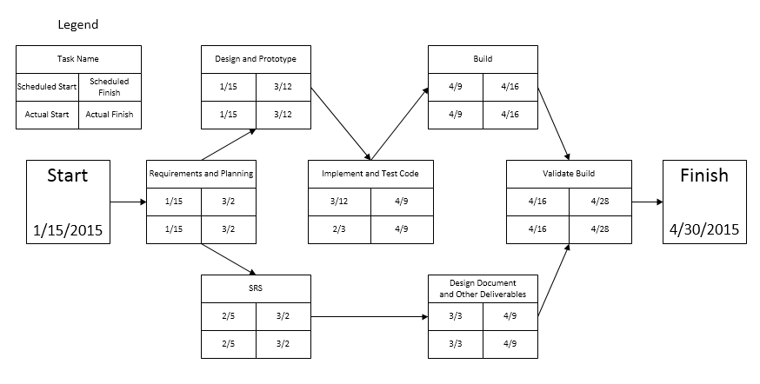

## Appendix B: Diagrams

**Figure 6.2.0-1** Data Requirements (*Shown as E-R Data Model Diagram in IDEF1X notation*)

|  |
| --- |
|  |

### Basic Website Navigation Subsystem

**Figure 6.2.1-1** Website Navigation Use Case Diagram

|  |
| --- |
|  |

**Figure 6.2.1-2** Suggestion Submission Sequence Diagram

|  |
| --- |
|  |

### Login Subsystem

**Figure 6.2.2-1** Login Use Case Diagram

|  |
| --- |
|  |

**Figure 6.3.2-2** Registration Sequence Diagram

|  |
| --- |
|  |

### User Profile Subsystem

**Figure 6.2.3-1** User Profile Use Case Diagram

|  |
| --- |
|  |

**Figure 6.3.2-2** Profile Image Deletion

|  |
| --- |
|  |

### Administrative Tools Subsystem

**Figure 6.3.4-1** Administrative Tools Use Case Diagram

|  |
| --- |
|  |

**Figure 6.2.4-2** Read Administrative Messages Sequence Diagram

|  |
| --- |
|  |

### Discussion Subsystem

**Figure 6.2.5-1** Discussion Use Case Diagram

|  |
| --- |
|  |

**Figure 6.2.5-2** View Discussion Page Sequence Diagram

|  |
| --- |
|  |

### Calendar of Events Subsystem

**Figure 6.2.6-1** Calendar of Events Use Case Diagram

|  |
| --- |
|  |

**Figure 6.2.6-2** Calendar Navigation Sequence Diagram

|  |
| --- |
|  |

## Appendix C: User Interface Designs

### Pages

**Figure 6.3.1-1 Welcome Page**

|  |
| --- |
|  |

**Figure 6.3.1-2** Navigation Bar

|  |
| --- |
|  |

**Figure 6.3.1-3** Navigation Bar Dropdown Menus

|  |
| --- |
|  |

**Figure 6.3.1-4** Home Page

|  |
| --- |
|  |

**Figure 6.3.1-5** Page Footer

|  |
| --- |
|  |

**Figure 6.3.1-6** Calendar of Events

|  |
| --- |
|  |

**Figure 6.3.1-7** Videos

|  |
| --- |
|  |

### Forms

**Figure 6.3.2-1** Sign-In Form

|  |
| --- |
|  |

**Figure 6.3.2-2** Registration Form

|  |
| --- |
|  |

**Figure 6.3.2-3** Suggestions Form

|  |
| --- |
|  |

## Class Diagrams

Below are UML class diagrams showing attributes and methods for each class grouped by packages. Due to the size of the packages a representative sample of the controller and models classes have been provided.

### Content Package Class Diagram

Representative sample of the classes within the content package

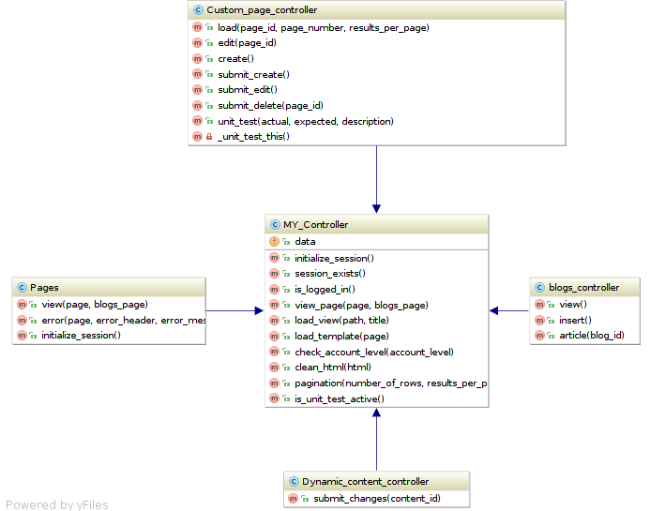

### Administrator Dashboard Package

The dashboard controller within the dashboard package.

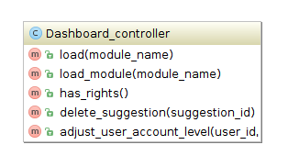

### Calendar Package

The calendar controller within the calendar package.

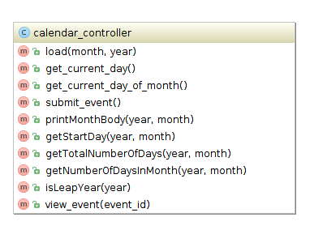

### Search Package

The search controller within the search package.

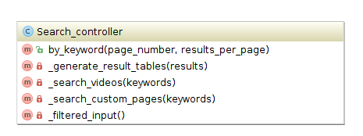

### Login Package

Class diagram of the login package controllers.

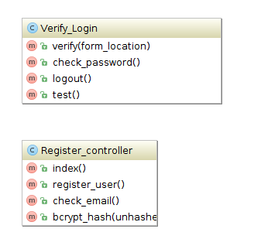

### Package Models

A representative sample of the model classes in the Film Club CMS. The User model is part of the login package and the dynamic_content and custom_pages classes belong to the content package.

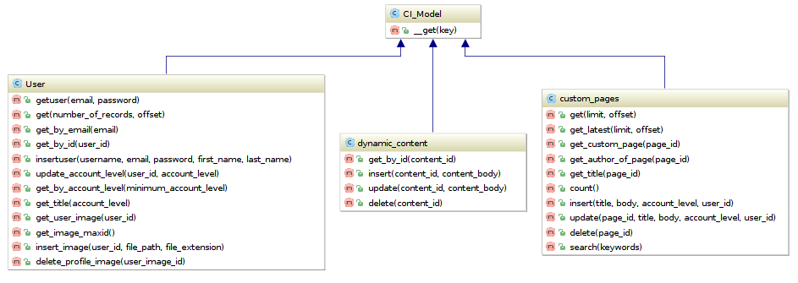

## Class Interfaces

Please refer to the Film Club CMS API pages generated in phpDoc.

## Testing

Please refer to the Film Club CMS API pages generated in phpDoc for the documented code for the testing driver.

### Selenium Tests & Screens

This section contains screen captures saved from the testing process. Note that not all test screens are listed.

TC_001_Test1

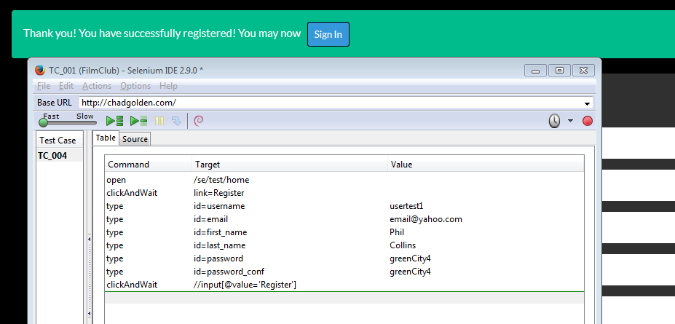

TC_001_Test2

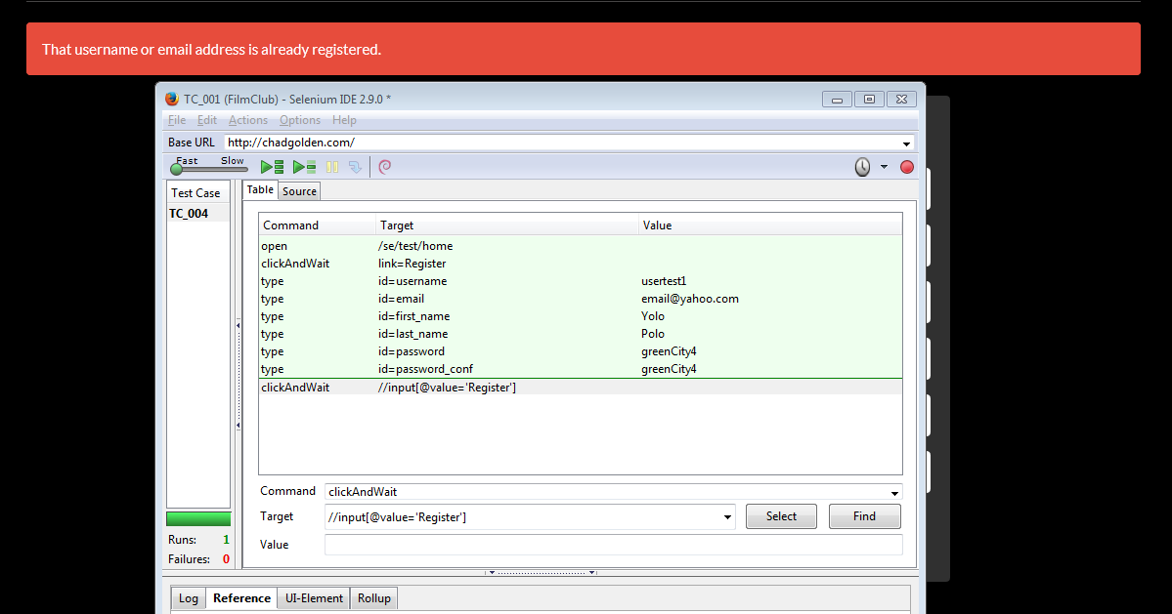

TC_001_Test3

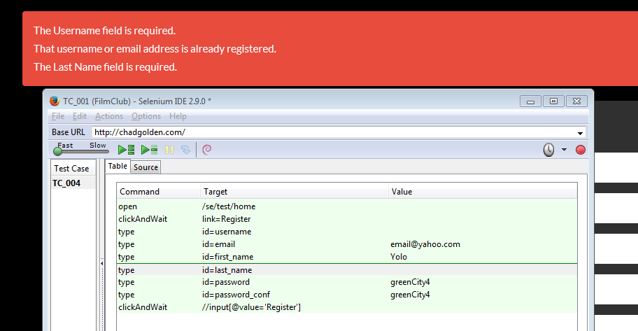

TC_002_Test1

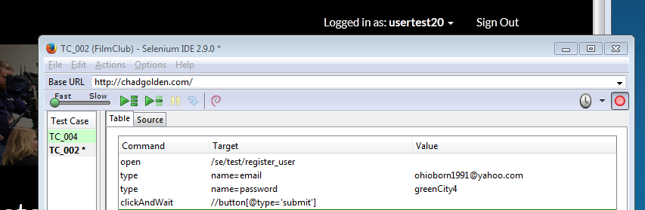

TC_002_Test2

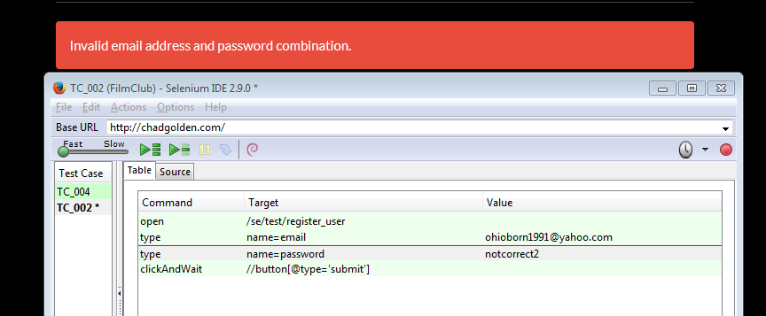

TC_002_Test3

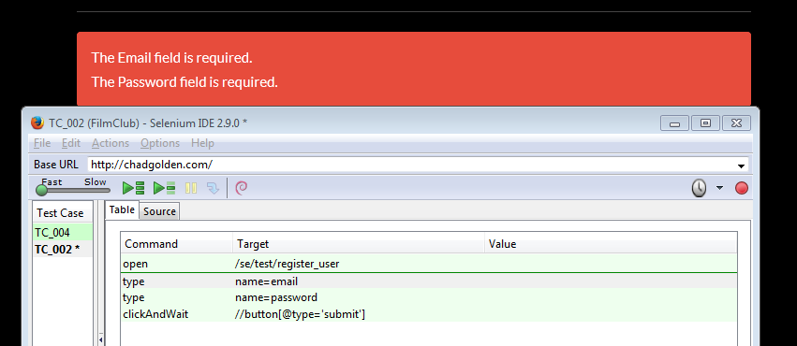

TC_003_Test1

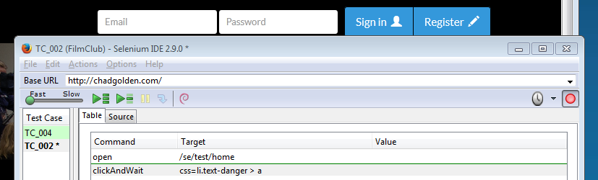

TC_005_Test1

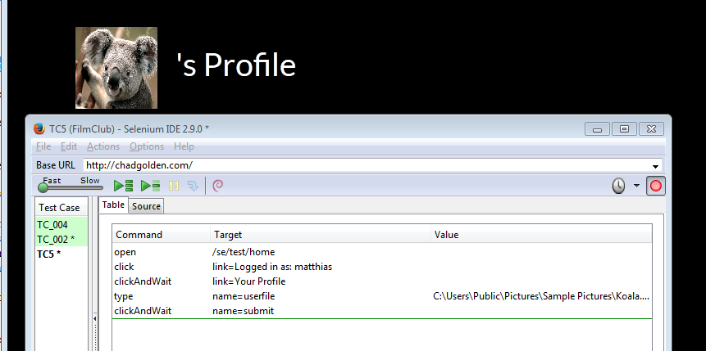

TC_005_Test2

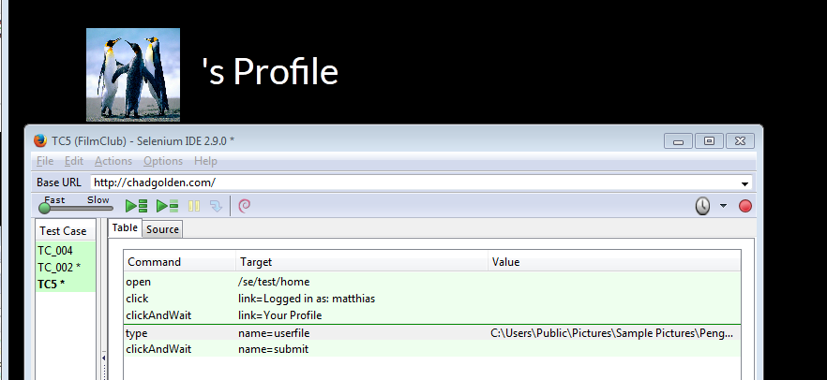

TC_005_Test3

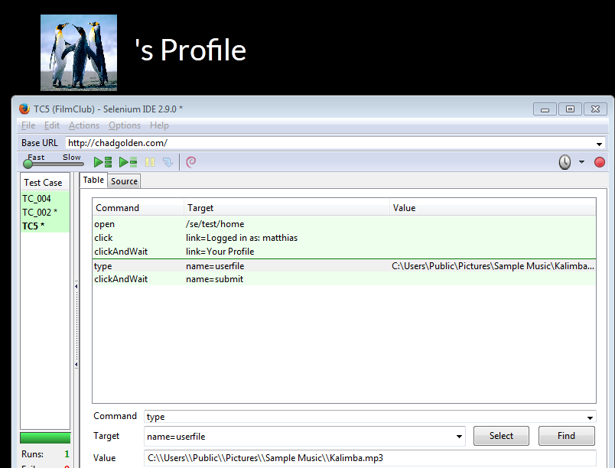

TC_006_Test1

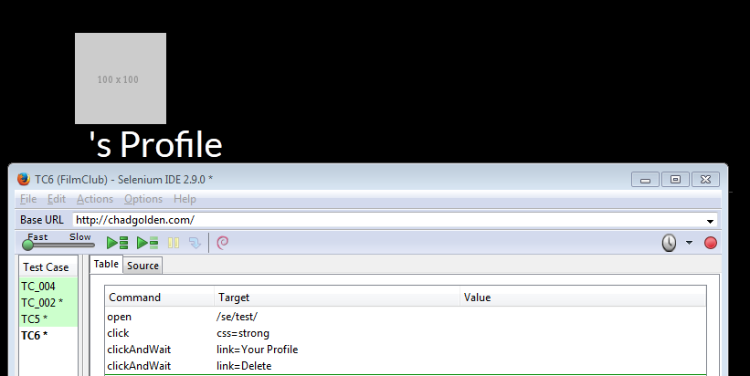

TC_006_Test2

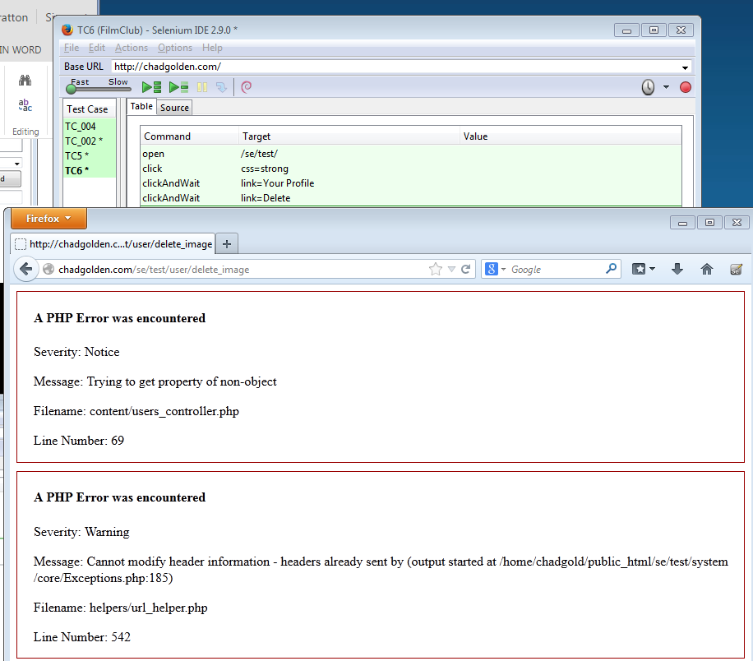

TC_007_Test1

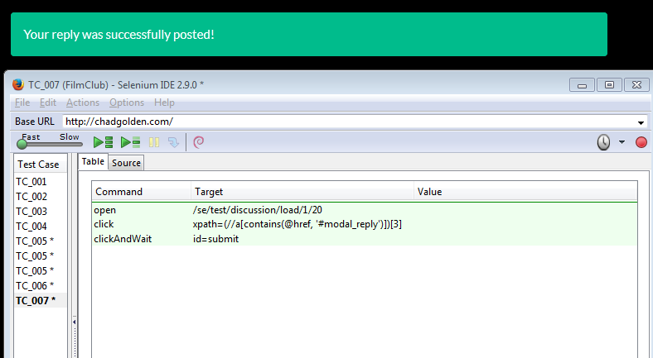

TC_007_Test2

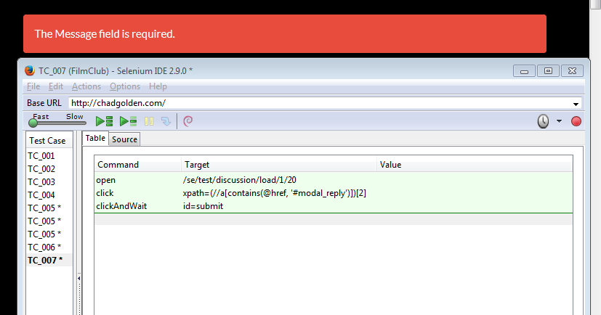

TC_007_Test3

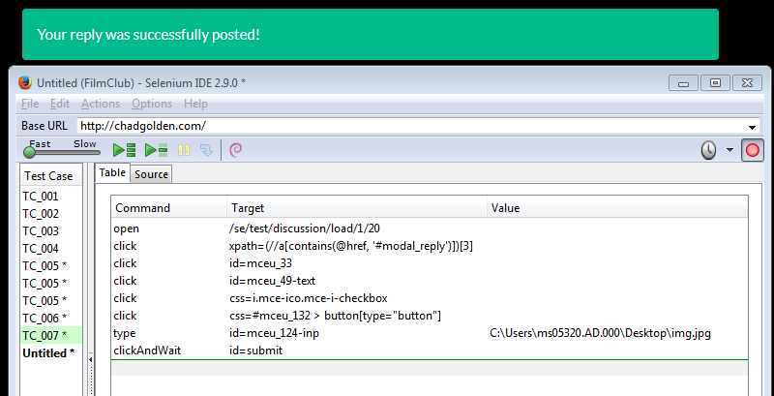

TC_007_Test4

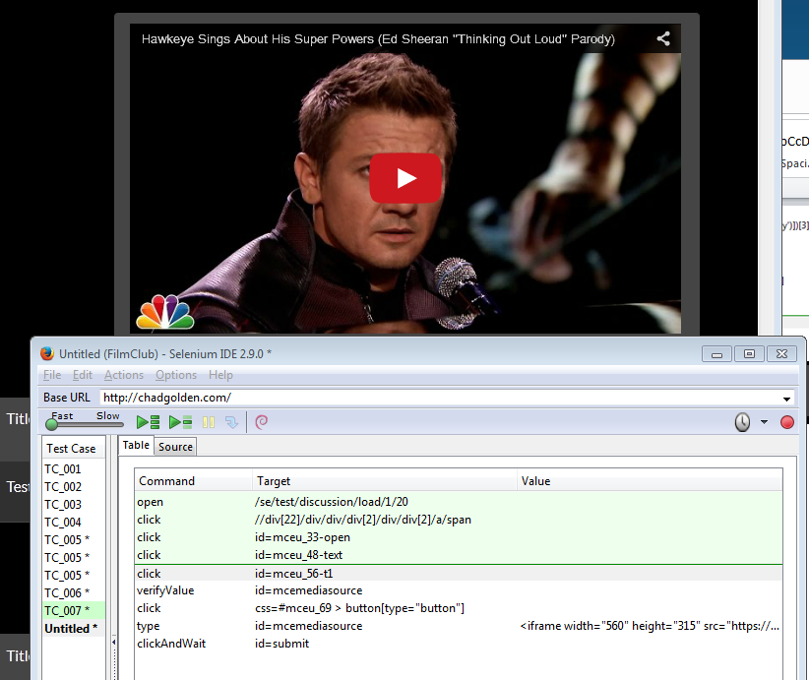

TC_008_Test1

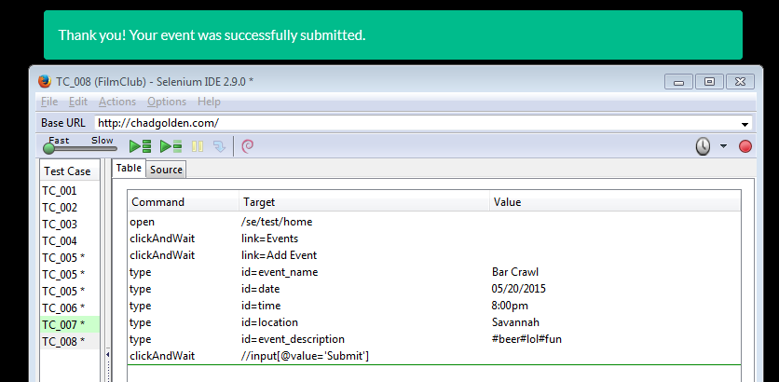

TC_010_Test1

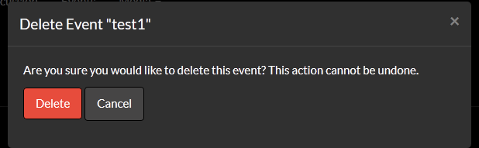

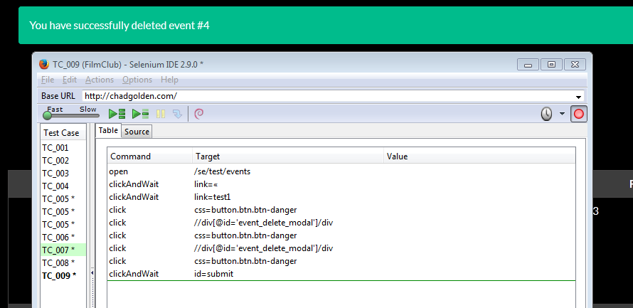

TC_012_Test1



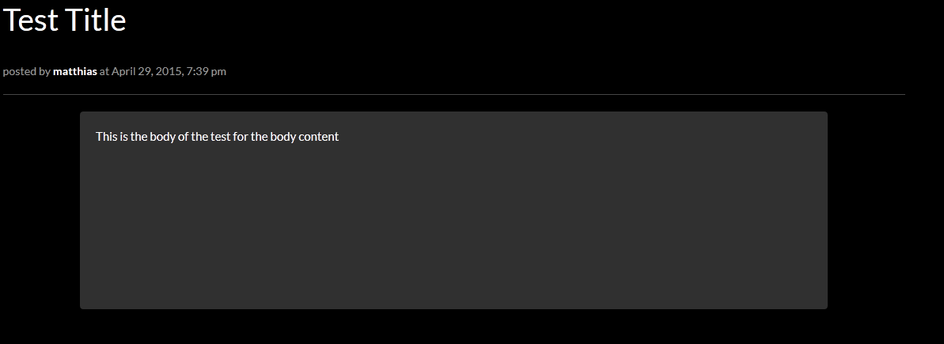

TC_012_Test2

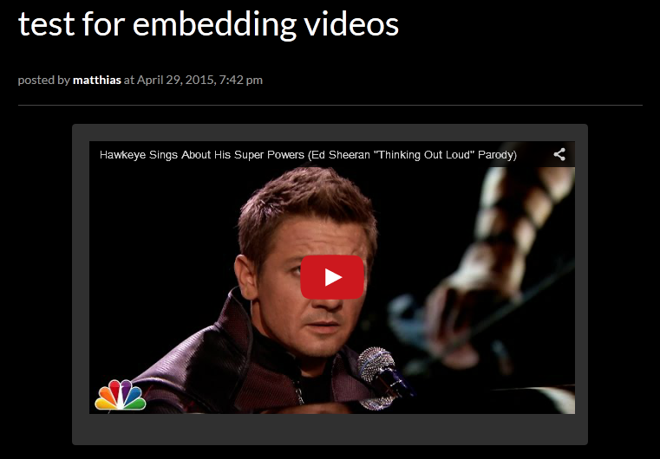

TC_012_Test3

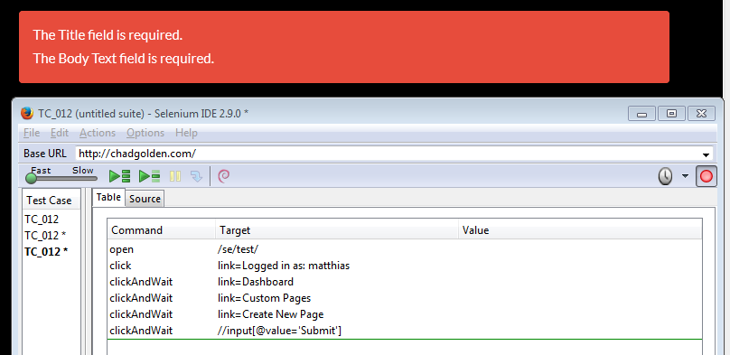

TC_013_Test1

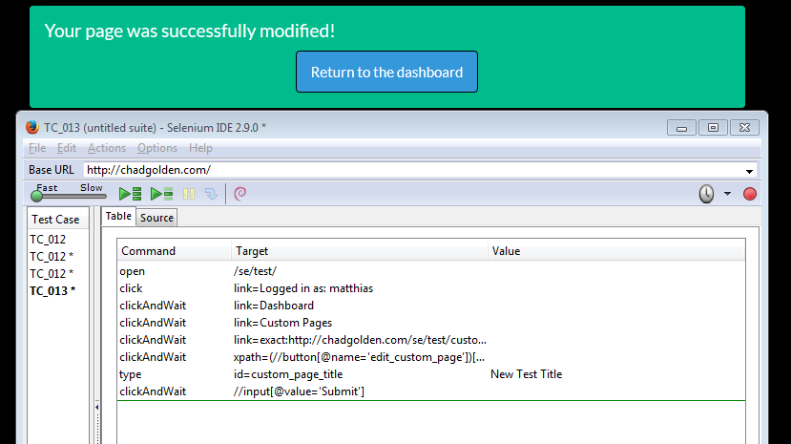

TC_013_Test3

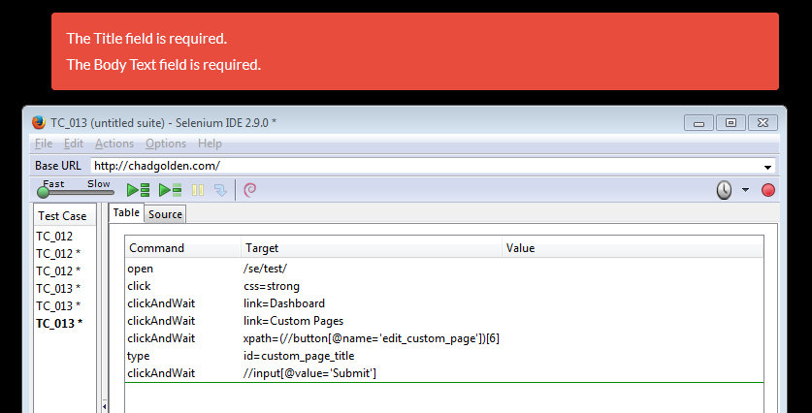

TC_014_Test1

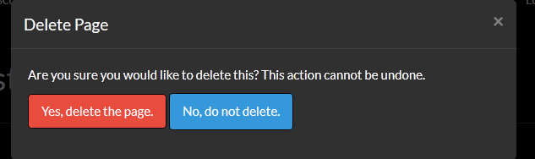

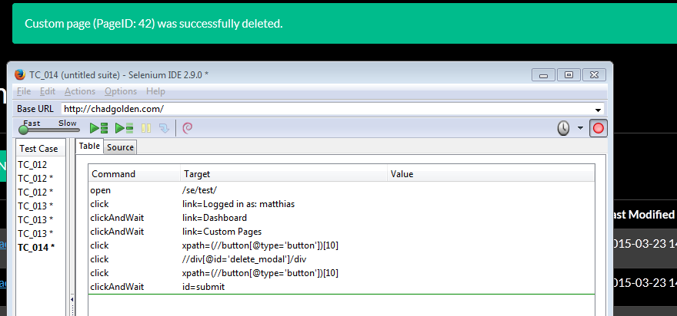

TC_015_Test1

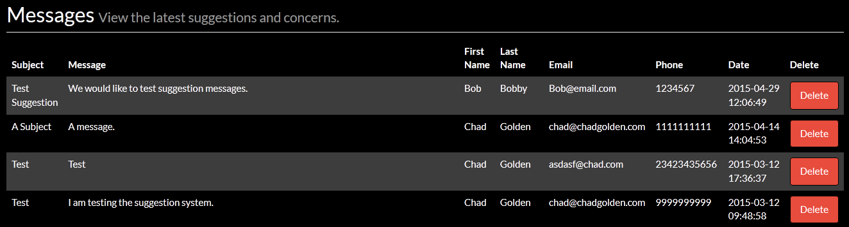

TC_016_Test1





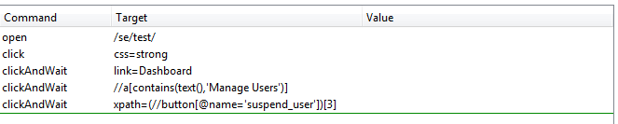

TC_017_Test1



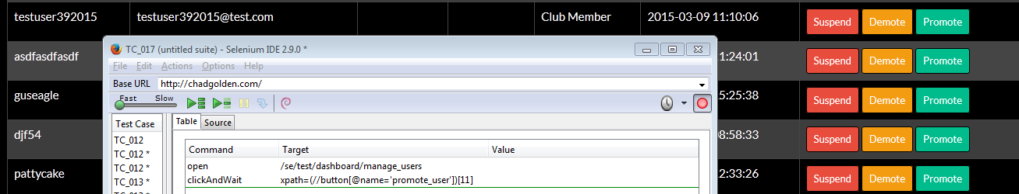

TC_017_Test2



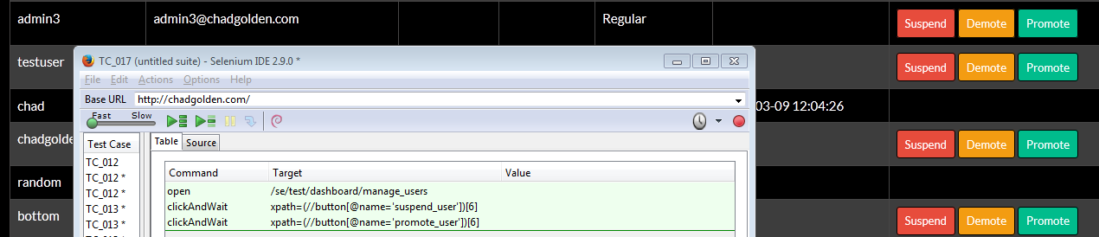

TC_018_Test1

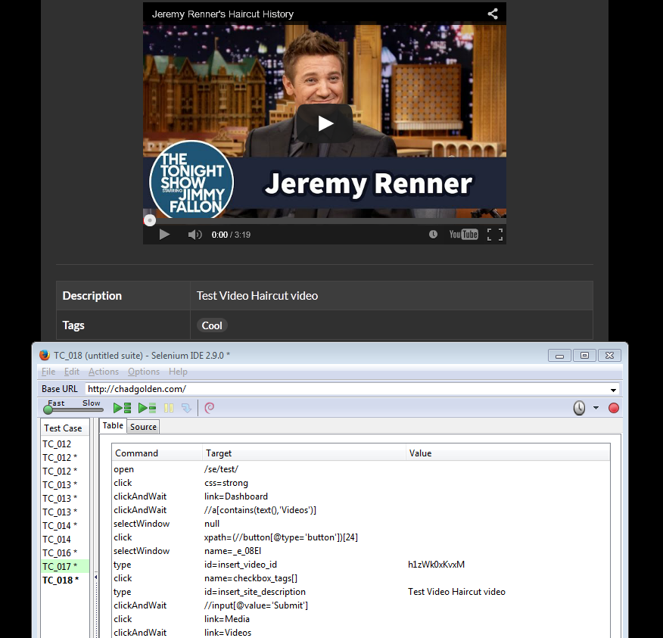

TC_018_Test2

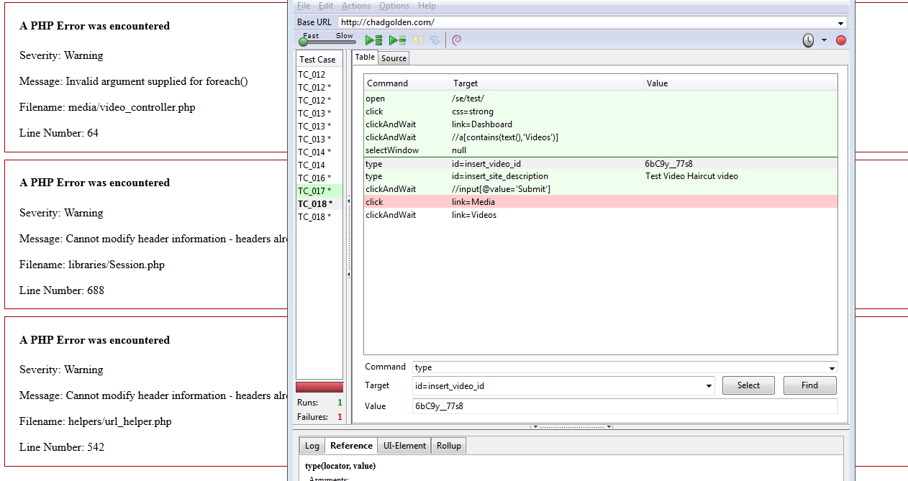

TC_018_Test3



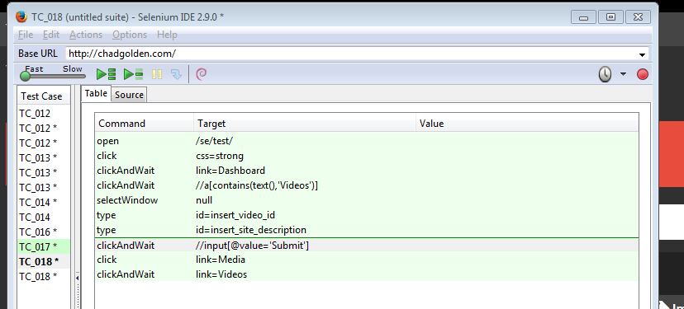

TC_019_Test1

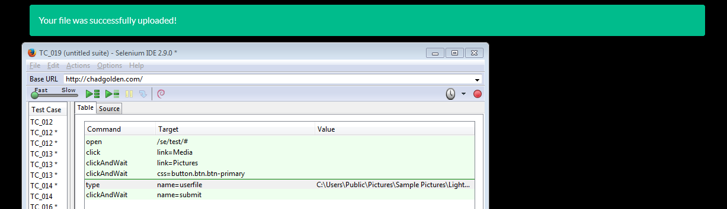

TC_020_Test1





TC_020_Test2

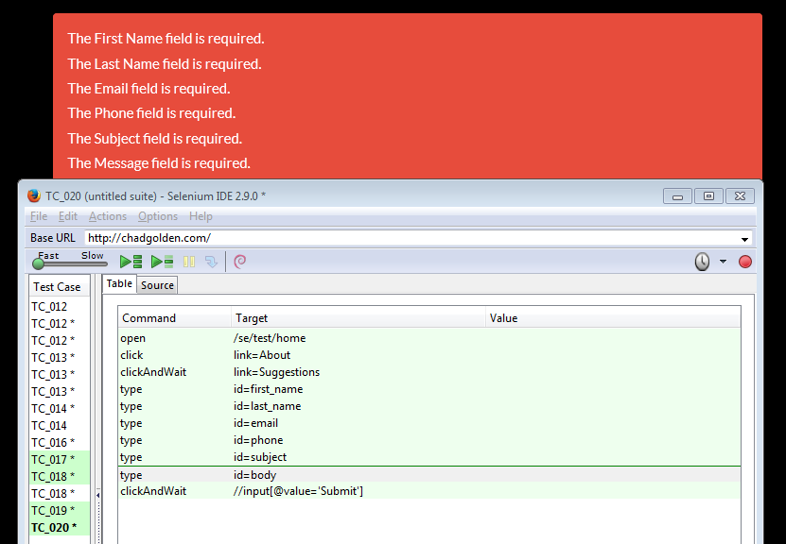

TC_023_Test1

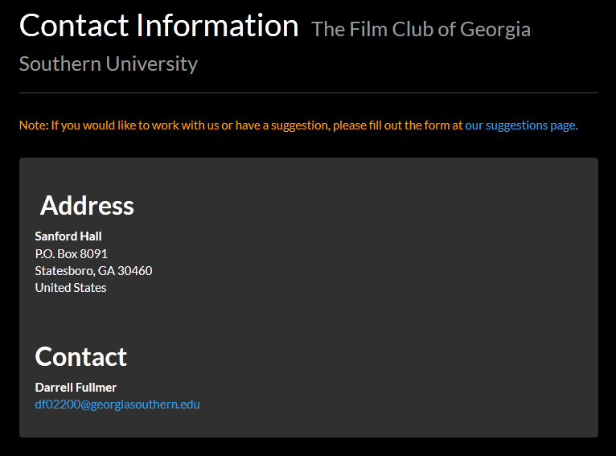

TC_025_Test1

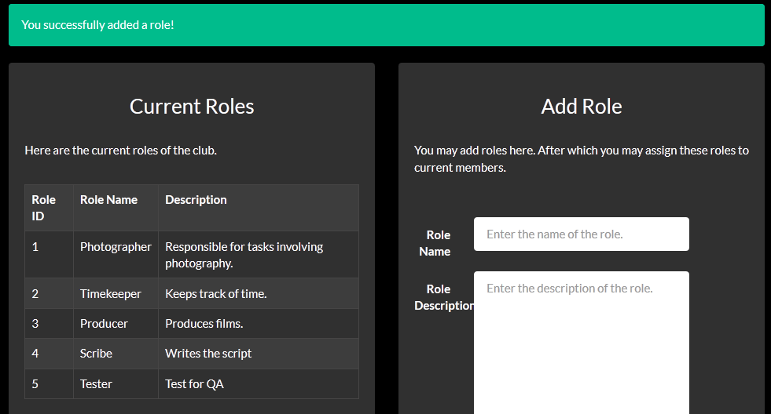

TC_026_Test1

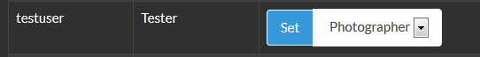

TC_026_Test2

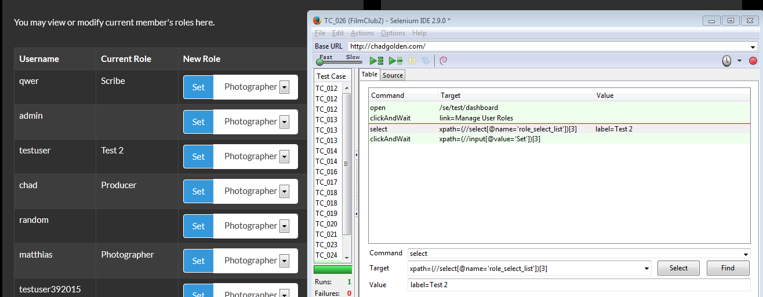

## References

[**Meyer, Bertrand**](http://en.wikipedia.org/wiki/Bertrand_Meyer)**(1988). Object-Oriented Software Construction. Prentice Hall.**[**ISBN**](http://en.wikipedia.org/wiki/International_Standard_Book_Number)[**0-13-629049-3**](http://en.wikipedia.org/wiki/Special:BookSources/0-13-629049-3)**.**

**Agile Alliance. What is Agile Software Development? http://www.agilealliance.org/the-alliance/what-is-agile/.**

## Appendix D: Diary of Meeting and Tasks

**Table 6.4-1**

|  |  |
| --- | --- |
| **Date** | 01/14/2015 |
| **Location** | IT Building |
| **Start Time** | 6:00 PM |
| **End Time** | 6:30 PM |
| **In Attendance** | Lamar Sims  Matthew Stratton |
| **Agenda** | Initial Meeting with the Client  Discussion of Plans and Client Needs |
| **Summary of Discussion** | Lamar and Matthew talked with Darrell about what would be beneficial to his club. He told us that a web system to manage events and engage members is… |

**Table 6.4-2**

|  |  |
| --- | --- |
| **Date** | 02/3/2015 |
| **Location** | IT Building Room 3214 |
| **Start Time** | Noon |
| **End Time** | 2:00 PM |
| **In Attendance** | Chad Golden  O’Neal Jones |
| **Agenda** | Discussion of Languages and Concepts of Web Applications |
| **Summary of Discussion** | Discussed PHP concepts and how to handle sessions. Decided that sessions and other baseline data would best be handled by an abstract controller class as part of a Model-View-Controller (MVC) architecture. |

**Table 6.4-3**

|  |  |
| --- | --- |
| **Date** | 2/4/2015 |
| **Location** | IT Room 3214 |
| **Start Time** | 11:30 AM |
| **End Time** | 12:30 PM |
| **In Attendance** | Chad Golden  O’Neal Jones |
| **Agenda** | Web Page Design |
| **Summary of Discussion** | Designed a “Dashboard” page and explored how the page would interact with a database backend. Added a “privilege level” field within the PHP session so that the page may only be accessed by those users with high privilege levels. |

**Table 6.4-4**

|  |  |
| --- | --- |
| **Date** | 02/5/2015 |
| **Location** | IT Building |
| **Start Time** | 6:00 PM |
| **End Time** | 6:30 PM |
| **In Attendance** | Chad Golden  Lamar Sims  Matthew Stratton |
| **Agenda** | Meeting with the Client  Discussion of Plans and Client Needs |
| **Summary of Discussion** | Lamar, Matthew and Chad talked with Darrell about what would be beneficial to his club. |

**Table 6.4-5**

|  |  |
| --- | --- |
| **Date** | 2/10/2015 |
| **Location** | IT Room 3214 |
| **Start Time** | Noon |
| **End Time** | 4PM |
| **In Attendance** | Chad Golden  O’Neal Jones  Patrick Meehan  Matthew Stratton |
| **Agenda** | Exploration of Web Application Concepts |
| **Summary of Discussion** | Made sure everyone was up to speed on the basics of websites and web application design. Did a walkthrough of how to dynamically generate content on web pages using PHP and a database. In the process the group built a “Blog” system where a user types in a body and message in order to create a page for the blog and an entry on a page querying the database for all blogs. |

**Table 6.4-6**

|  |  |
| --- | --- |
| **Date** | 2/11/2015 |
| **Location** | IT Room 3214 |
| **Start Time** | 11:30 AM |
| **End Time** | 12:45 PM |
| **In Attendance** | Chad Golden  O’Neal Jones |
| **Agenda** | Discussed More Web Application Concepts |
| **Summary of Discussion** | Experimented with MVC architectures and how models, views, and controller classes interact with one another within a PHP application. Walked through HTML form validation techniques. |

**Table 6.4-7**

|  |  |
| --- | --- |
| **Date** | 2/12/2015 |
| **Location** | IT Room 3214 |
| **Start Time** | 1:00 PM |
| **End Time** | 4:00 PM |
| **In Attendance** | Chad Golden  O’Neal Jones |
| **Agenda** | Web Page Design |
| **Summary of Discussion** | Designed some prototypical pages and started formulation of some back-end logic for the pages. |

**Table 6.4-8**

|  |  |
| --- | --- |
| **Date** | 02/12/2015 |
| **Location** | IT Building |
| **Start Time** | 6:00 PM |
| **End Time** | 6:30 PM |
| **In Attendance** | Chad Golden  Lamar Sims |
| **Agenda** | Meeting with the Client  Discussion of Plans and Client Needs |
| **Summary of Discussion** | Lamar and Chad talked with Darrell about what would be beneficial to his club. |

**Table 6.4-9**

|  |  |
| --- | --- |
| **Date** | 2/17/2015 |
| **Location** | IT Room 3214 |
| **Start Time** | Noon |
| **End Time** | 4:00 PM |
| **In Attendance** | Chad Golden  O’Neal Jones  Lamar Sims |
| **Agenda** | Calendar Logic |
| **Summary of Discussion** | Darrell made it clear that he wanted a calendar of events. Chad, O’Neal, and Lamar began plugging in some back-end components to the calendar page created previously. |

**Table 6.4-10**

|  |  |
| --- | --- |
| **Date** | 2/19/2015 |
| **Location** | IT Room 3214 |
| **Start Time** | Noon |
| **End Time** | 4:00 PM |
| **In Attendance** | Chad Golden  O’Neal Jones  Patrick Meehan |
| **Agenda** | Web Page Design and Calendar Logic |
| **Summary of Discussion** | Added useful links to the footer. Did more implementation of calendar logic to the calendar of events page. The calendar can now be navigated correctly. |

**Table 6.4-11**

|  |  |
| --- | --- |
| **Date** | 2/24/2015 |
| **Location** | IT Room 3214 |
| **Start Time** | Noon |
| **End Time** | 4:00 PM |
| **In Attendance** | The Team |
| **Agenda** | SRS Tasks |
| **Summary of Discussion** | Made sure everyone was clear on their role for the completion of the SRS. Each team member worked on their particular role for the span of the meeting. |

**Table 6.4-12**

|  |  |
| --- | --- |
| **Date** | 2/26/2015 |
| **Location** | IT Room 3214 |
| **Start Time** | Noon |
| **End Time** | 4:00 PM |
| **In Attendance** | Chad Golden  O’Neal Jones  Lamar Sims  Matthew Stratton |
| **Agenda** | SRS Tasks |
| **Summary of Discussion** | Each member in attendance further worked on completion of the SRS. |

**Table 6.4-13**

|  |  |
| --- | --- |
| **Date** | 3/5/2015 |
| **Location** | IT Room 3314 |
| **Start Time** | 11:00AM |
| **End Time** | 1:30PM |
| **In Attendance** | Chad Golden  Lamar Sims  Matthew Stratton |
| **Agenda** | Web Page Design and Functionality |
| **Summary of Discussion** | Improved Photo Gallery layout and came up with new plan for the discussion page based on client reviews. |

**Table 6.4-14**

|  |  |
| --- | --- |
| **Date** | 3/10/2015 |
| **Location** | IT Room 3214 |
| **Start Time** | 10:30AM |
| **End Time** | 1:30PM |
| **In Attendance** | The Team |
| **Agenda** | Improve website |
| **Summary of Discussion** | Focused on small details of the website and functionality. |

**Table 6.4-15**

|  |  |
| --- | --- |
| **Date** | 3/17/2015 |
| **Location** | IT Room 3214 |
| **Start Time** | 12:30AM |
| **End Time** | 1:30PM |
| **In Attendance** | Chad Golden  O’Neal Jones  Lamar Sims |
| **Agenda** | Profile Photo Functionality |
| **Summary of Discussion** | The functionality to add a profile photo to an account was improved. Other details of the website were also worked on. |

**Table 6.4-16**

|  |  |
| --- | --- |
| **Date** | 3/19/2015 |
| **Location** | IT Room 3214 |
| **Start Time** | 11:30AM |
| **End Time** | 1:30PM |
| **In Attendance** | Chad Golden  O’Neal Jones  Lamar Sims  Patrick Meehan |
| **Agenda** | Website design and fixing bugs |
| **Summary of Discussion** | Improved layout and some small issues were worked on. |

**Table 6.4-17**

|  |  |
| --- | --- |
| **Date** | 3/26/2015 |
| **Location** | IT Room 3214 |
| **Start Time** | 12:30AM |
| **End Time** | 3:30PM |
| **In Attendance** | Chad Golden  O’Neal Jones  Lamar Sims  Matthew Stratton |
| **Agenda** | Discussion Page and Dashboard improvements |
| **Summary of Discussion** | Chad, Lamar, and O'Neal worked on the dashboard feature, Matthew worked on improving the Discussion page. |

**Table 6.4-18**

|  |  |
| --- | --- |
| **Date** | 3/30/2015 |
| **Location** | The Williams Center |
| **Start Time** | 2:00PM |
| **End Time** | 3:30PM |
| **In Attendance** | Matthew Stratton  Darrell Fulmer |
| **Agenda** | Meet Film Club Officers and get feedback |
| **Summary of Discussion** | Matthew met with Darrell and the other officers of the Film Club. Got feedback from several officers which included   * Twitter Feed Design * Discussion Page Design * Access to certain features depending on level   Also got information regarding the faculty supervisor to begin planning web hosting from GSU. |

**Table 6.4-19**

|  |  |
| --- | --- |
| **Date** | 4/2/2015 |
| **Location** | IT Room 3214 |
| **Start Time** | 12:30PM |
| **End Time** | 2:30PM |
| **In Attendance** | The Team |
| **Agenda** | Begin planning of Final Requirements Document |
| **Summary of Discussion** | The team decided what needed to be changed with the old document, Lamar and Matthew started to look into testing tools, and O'Neal began to plan out a User Guide. |

**Table 6.4-20**

|  |  |
| --- | --- |
| **Date** | 4/7/2015 |
| **Location** | IT Room 3214 |
| **Start Time** | 11:30AM |
| **End Time** | 4:00PM |
| **In Attendance** | Chad Golden  Lamar Sims |
| **Agenda** | Improve Dashboard Functionality |
| **Summary of Discussion** | Chad and Lamar improved the features of the dashboard and fixed bugs relating to functionality. |

**Table 6.4-21**

|  |  |
| --- | --- |
| **Date** | 4/9/2015 |
| **Location** | IT Room 3214 |
| **Start Time** | 12:30PM |
| **End Time** | 4:00PM |
| **In Attendance** | Chad Golden  Lamar Sims  O'Neal Jones  Matthew Stratton |
| **Agenda** | Improve Dashboard Functionality and discussion page. |
| **Summary of Discussion** | Improve the features of the dashboard and fix database bugs. Begin to reformat the discussion page from clients input. |

**Table 6.4-22**

|  |  |
| --- | --- |
| **Date** | 4/16/2015 |
| **Location** | IT Room 3214 |
| **Start Time** | 11:30AM |
| **End Time** | 3:00PM |
| **In Attendance** | The Team |
| **Agenda** | Work on Final Requirements Document. |
| **Summary of Discussion** | The Final Requirements Document was worked on and improved. |

**Table 6.4-23**

|  |  |
| --- | --- |
| **Date** | 4/21/2015 |
| **Location** | IT Room 3214 |
| **Start Time** | 1:30PM |
| **End Time** | 4:00PM |
| **In Attendance** | Chad Golden  Lamar Sims |
| **Agenda** | Fix database bugs |
| **Summary of Discussion** | Chad and Lamar worked on some database errors regarding the photo gallery. |

**Table 6.4-24**

|  |  |
| --- | --- |
| **Date** | 4/23/2015 |
| **Location** | IT Room 3214 |
| **Start Time** | 11:30AM |
| **End Time** | 3:00PM |
| **In Attendance** | Chad Golden  O'Neal Jones |
| **Agenda** | Improve Website and work on Final Requirements Document |
| **Summary of Discussion** | Fix up some bugs with the website and work on Final Requirements Document. |

**Table 6.4-25**

|  |  |
| --- | --- |
| **Date** | 4/28/2015 |
| **Location** | IT Room 3214 |
| **Start Time** | 11:30AM |
| **End Time** | 4:00PM |
| **In Attendance** | Chad Golden  Lamar Sims  O'Neal Jones  Matthew Stratton |
| **Agenda** | Concluding on Final Requirements Document |
| **Summary of Discussion** | The team has collaborated since last week on the Final Requirements Document. The website is near completion and now individual roles regarding documentation are being supervised. Testing is near complete. |

**Table 6.4-26**

|  |  |
| --- | --- |
| **Date** | 5/1/2015 |
| **Location** | IT Room 3214 |
| **Start Time** | 10:30AM |
| **End Time** | 4:00PM |
| **In Attendance** | Chad Golden  Lamar Sims  Matthew Stratton |
| **Agenda** | Final Touches |
| **Summary of Discussion** | The Final Requirements Document is complete. Tweaks and small details are added before finally being submitted to Dr. Allen. |